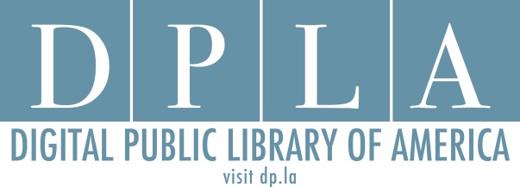

Ohio DPLA Steering Committee Meeting

State Library of Ohio

December 2, 2015

3:00-5:00 p.m.

* Symposium – Final Details Review
* Discussion Time with Emily and Amy
* Survey 2 Questions and Schedule Discussion
* Survey 1 Distribution Plan
* Working group reports/questions
* Wrap-up
  + Dinner details