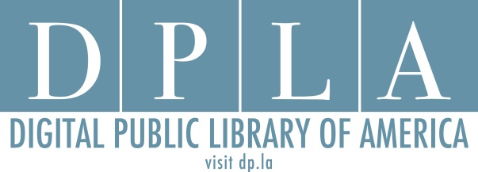
Ohio DPLA Steering Committee Meeting
State Library of Ohio
December 2, 2015
3:00-5:00 p.m.

- Symposium – Final Details Review

- Discussion Time with Emily and Amy

- Survey 2 Questions and Schedule Discussion

- Survey 1 Distribution Plan

- Working group reports/questions

- Wrap-up
  - Dinner details

