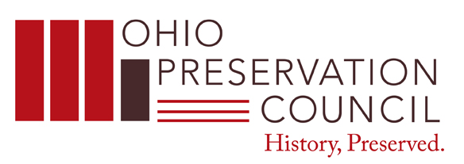
January 23, 2013
Dear Colleague:

This letter is your invitation to continue supporting preservation efforts for Ohio’s documentary and cultural heritage by joining or renewing your membership in the Ohio Preservation Council (OPC) for the 2013 calendar year. The Ohio Preservation Council serves as a coalition of preservationists, conservators, librarians, archivists, curators, records managers, the institutions they represent, and other concerned citizens who recognize the serious threat to documentary heritage. The Council's mission is to provide a network for preservation education and to support preservation activities within the state of Ohio.

The OPC offers a number of opportunities for members to become involved with preservation efforts statewide:

• Preservation training and instruction
• Participation in specialized projects and symposia
• Council standing committees
• Networking opportunities with colleagues at other Ohio institutions

The OPC is an indispensable resource for learning and networking with other Ohio professionals whose dedication, experience and support cannot be undervalued. Membership meetings are held on the third Thursday of March, May, September and November. Meetings often include “behind the scenes” tours of cultural facilities complete with demonstrations of specialized skills by members and guests. All members are invited to attend meetings. See the OPC website for meeting locations and times at http://opc.ohionet.org for a list of member institutions, and information regarding past and upcoming events.

Membership in the OPC runs from January to December of the calendar year. Please consider helping us meet preservation needs in Ohio by visiting: http://opc.ohionet.org/opcjoomla/membership/how-to-join to initiate your membership. New members should click on the link that says “Join OPC as a new member” to create a profile for themselves or their institution. Alternatively, an invoice can be e-mailed to you.

Checks should be made payable to “Ohio Preservation Council” and mailed to:

Ohio Preservation Council
OHIONET attn: Jennifer Turner
1500 W. Lane Avenue
Columbus, Ohio 43221-3975

Yours sincerely,

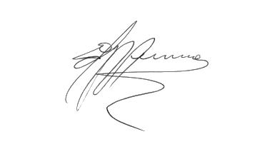

Ed Vermue
Chair, Ohio Preservation Council
Email: ed.vermue@oberlin.edu
Phone: (440) 775-5043

