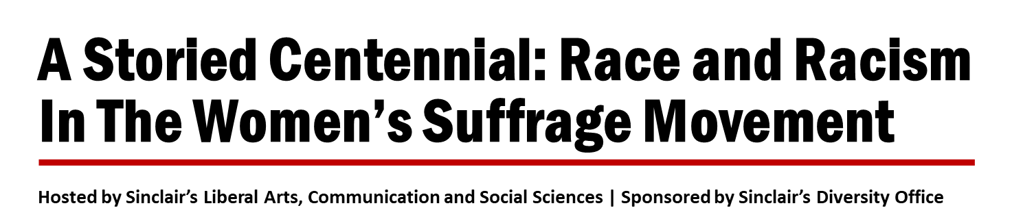

Click HERE to register for this virtual event

Dr. Treva Lindsey, Associate Professor at The Ohio State University, will join Furaha Henry-Jones, Professor at Sinclair, for this webinar to explore the portrayal of race and the role of racism during the Women’s Suffrage Movement. Please consider setting aside time to participate in this webinar! The bios of Dr. Lindsey and Prof. Henry-Jones are below

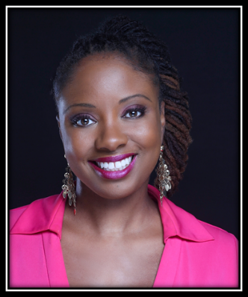
Dr. Treva Lindsey is an Associate Professor at The Ohio State University. Her research and teaching interests include African American women’s history, black popular and expressive culture, black feminism(s), hip hop studies, critical race and gender theory, and sexual politics. Her first book, Colored No More: Reinventing Black Womanhood in Washington D.C is a Choice 2017 “Outstanding Academic Title.” She has published in The Journal of Pan-African Studies, Souls, African and Black Diaspora, the Journal of African American Studies, African American Review, The Journal of African American History, Meridians: Feminism, Race, Transnationalism, Urban Education, The Black Scholar, Feminist Studies, and Signs. She is a 2020-2021 ACLS/Mellon Scholars and Society Fellow. She was the inaugural Equity for Women and Girls of Color Fellow at Harvard University (2016-2017). She received the 2018-2019 Ohio State University College of Arts and Sciences Diversity Enhancement Faculty Award. She is currently completing her next book, America Goddam: Violence, Black Women, and The Struggle for Justice (University of California Press).

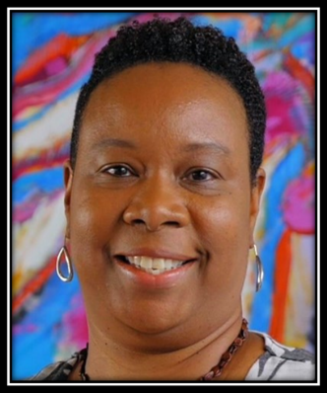
Furaha Henry-Jones is a Professor at Sinclair Community College, where she has served as co-founder of the Ubuntu South Africa Study Abroad Program, director of the Annual Sinclair Writers’ Workshop, co-chair of the Center for Teaching and Learning Diversity and Inclusion Professional Development Track, and member of the college’s American Council on Education’s Internationalization Lab. As a writer and professor, she has taught in public high schools and prisons, GED programs and college courses, charter schools for out-of-school youth, and migrant education programs. She was a recipient of the Ohio Arts Council Individual Excellence Award for Poetry, and she is serving her second term as Sinclair Poet Laureate. Her most recent work has centered on the oral performance of personal narrative poems and personal storytelling.

