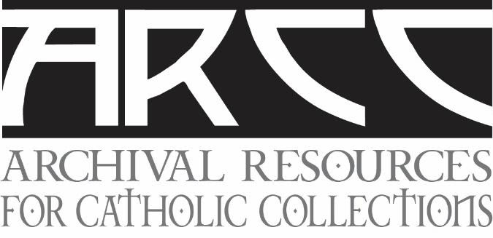
Repository Working Group
Collaborative Archives: Factors and Benefits
Wednesday, October 6, 2021
9 a.m. PDT 12 Noon EDT 4 p.m. GMT
Collaborative archives have become a primary focus for many institutions as a response to the need for preserving and making accessible Catholic religious community archival collections. Building on our November 2020 webinar outlining types of repositories [www.archivalrcc.org], this webinar examines the process of creating a collaborative archive.

Each panelist has experience conceiving, planning, and executing a collaborative repository. They will present their experience and lessons learned through participating in a collaborative archive project. In addition to addressing the cost benefits and efficiencies of collaborative archives, they will discuss how to:
- Develop a strategy for a collaborative archives
  - Evolving process of reaching an archival solution
  - Finding partners
  - Involving stakeholders – leadership and community
  - Importance of communication
  - Initial and long term benefits
- Determine financial support
- Address stumbling blocks
- Achieve long-term sustainability
Presenters:
Kingston, Ontario Collaborative Archive Project
- Rodney Carter, Archivist, Religious Hospitallers of Saint Joseph, Kingston, Ontario
- Veronica Stienburg, Archivist, Sisters of Providence of Saint Vincent de Paul, Kingston, Ontario
Society of the Sacred Heart, Saint Louis, Missouri
- Michael Pera, Archivist, Society of the Sacred Heart USA-Canada Province Archives
- Thomas More Daly, OSU, Archivist, Central Province Archives, Ursuline Sisters
Heritage and Research Center at Saint Mary’s, Notre Dame, Indiana
- Monte Abbott, Archivist, Sisters of the Good Shepherd Archives, Saint Louis, Missouri

Register by 5:00 pm EST/EDT on September 26 by clicking this link:
https://www.surveymonkey.com/r/VQTKLQR

