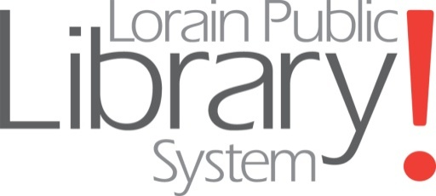

PART -TIME POSITION OPEN

ADMINISTRATIVE CLERK – ADMINISTRATION OFFICE
(Grade EF)

Basic Function: Performs a variety of clerical and business support related tasks in support of the administrative operations of the library.

Distinguishing Features of the Class:
This classification engages in responsible and varied clerical work requiring the exercise of judgment in the application of prescribed procedures and methods to routine matters. Work is done under general supervision of the Chief Fiscal Officer, Administrative Services Office Manager and/or Assistant Fiscal Officer.

Characteristic Duties and Responsibilities:
Monitors inventory of supplies for library system.
Takes minutes of the Board of Trustees meetings.
Makes travel arrangements and processes workshop and conference attendance registrations for staff and Trustees.
Assists Administrative Services Office Manager in the compilation of monthly and annual library statistical reports, using spreadsheets or library automation system report software. Digitizes records and assists with records retention management. Assists with fixed asset inventory, property tagging and property disposition. Inputs data for processing of purchase orders following library chart of accounts. Keeps/maintains accurate, detailed files and records for business office. Researches and processes purchases and resolves problems with vendors for system; keeps Chief Fiscal Officer informed on progress. Compiles reports and documents as required by library system managers and Chief Fiscal Officer. Types correspondence, reports, memoranda, etc. using electronic typewriter or PC. May serve as receptionist/switchboard operator for administrative office. Collects, counts, balances and prepares fine, copier and other revenues for deposit. Processes invoices for payment; establishes schedule for issuing checks. Files accounting documents and records regularly; assists Chief Fiscal Officer with records organization/retention. Assists in reconciliation of bank statements at month and year-end. Check in supply/equipment orders. Fills supply requisitions from department and branches. Oversees and assists with in-house mail, postage meter duties, and deliveries.

Knowledge, Skills and Abilities:
Good knowledge of office terminology, procedures and equipment; knowledge of business arithmetic and English; knowledge of bookkeeping and general accounting practices; ability to maintain complex clerical records and prepare reports from such records; ability to understand and carry out complex oral and written directions; ability to type 50 wpm; clerical aptitude; tact and courtesy; proficiency with 10 key adding machine, word processing and spreadsheet software; ability to work in a team environment; accuracy, integrity, and good judgment.

Education, Training and Experience:
Requires business school or college courses in accounting; a high school education or equivalent and at least two years of experience in clerical work including clerical-accounting duties and familiarity in using PC's, accounting practices, data entry or any equivalent combination of experience and training which provides the required knowledge, skills and abilities.

Supervisor: Administrative Services Office Manager and/or Assistant Fiscal Officer

Other: Part-time position, 30 hours/week. Primary schedule will be daytime hours, Monday through Friday. Schedule may include flexible daytime, evening and weekend hours. Duties include compiling statistical reports, Board minutes, conference, travel and event scheduling; may serve as back up for accounts payable and purchasing functions. Applicants must possess and demonstrate advanced computer skills using MS Office Suite including Word, PowerPoint and Excel. Some accounting training/experience helpful. Must have excellent customer service, interpersonal, communication, and organizational skills. Accounts payable and/or procurement experience helpful. Hiring range: ($13-$14) per hour, depending on qualifications and experience; limited benefits.

CLOSING DATE FOR APPLICATIONS: Until filled

APPLY TO: Administrative Office, Lorain Public Library System, 351 Sixth Street, Lorain, OH 44052, (440) 244-1192 ext 221 or visit our website www.lorain.lib.oh.us

EEO/EQUAL ACCESS AGENCY

