Hi everyone!
We still have 87 boxes (1,392 books) left of the Cleopatra books from our Egyptian merchandise . So, if anyone is interested, please contact us to get your free books! Here’s the information and a picture of the book from our order form:
Cleopatra: The Search for the Last Queen of Egypt by Zahi Hawass; 256 pages; ISBN: 978-1-4262-0545-3
Please send requests to: sutherli@smfpl.org
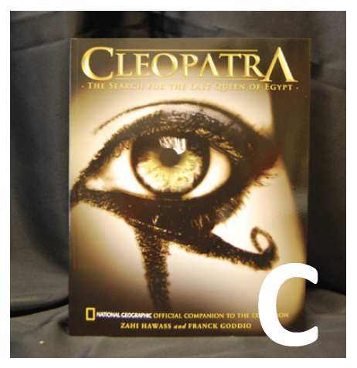
Thank you to everyone who’s already ordered books! It’s been such a great help!

