FREE Brother Intellifax 2820 Fax Machine
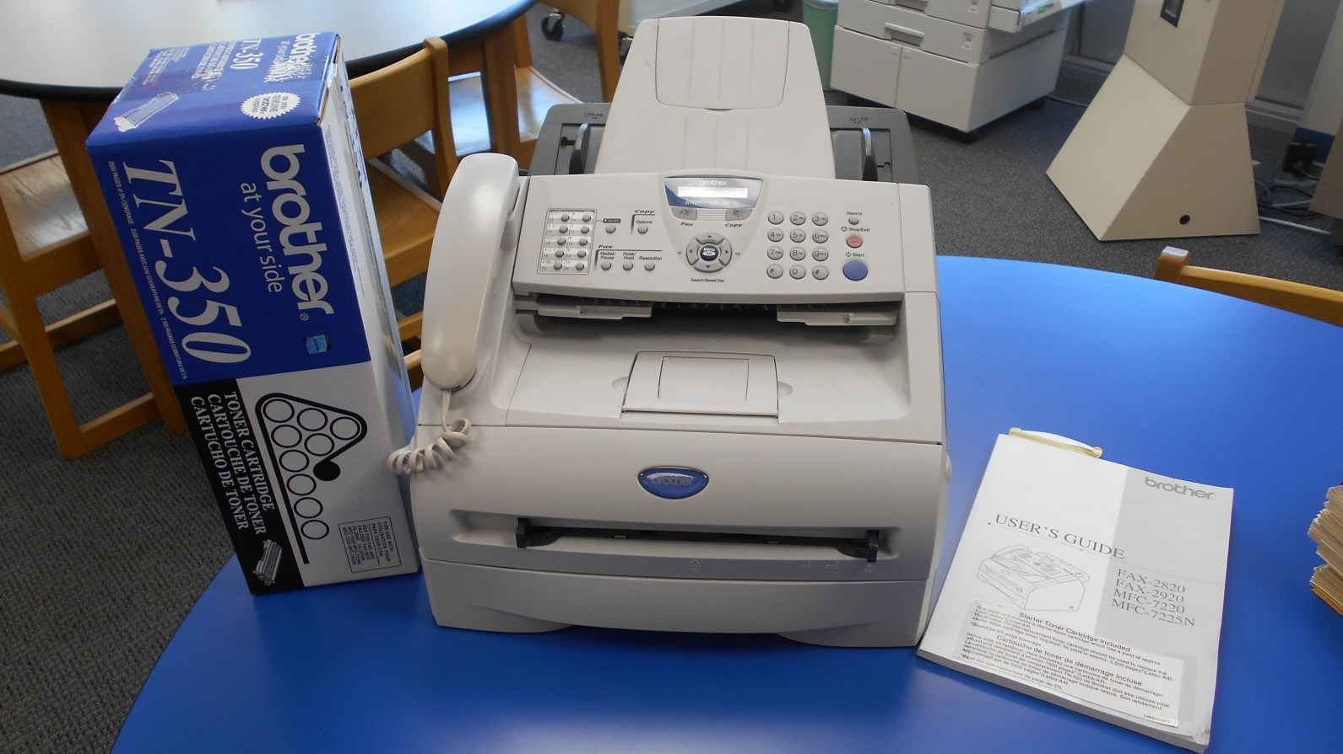
Have you ever imagined that you could take a document, shred it into millions of electronic impulses and send them, through the magic of the old-timey Telephone network, to anyone in the world who also has a fax machine?
Now you can! In the time it takes to wait in line for coffee, you could be Faxing to your heart’s content!
This device has been gently but regularly used; we assure you that it is in good working order and will serve you well for your future paper-to-analog signal conversion needs.
Comes with:
Users guide
1 new box of toner + 1 in the machine
Handset and cord
Power cord
Approx. 6 ft. 4-pin phone/data line
More feeder trays and plastic paper guides than you can shake a 28.8k modem at!
The machine is FREE, but the recipient must pick it up from:
Delta Public Library
402 Main Street
Delta, OH 43515
Questions?
Contact Clint Parry
419.822.3110
cparry@oplin.org

