FREE- Minolta RP 603Z Microfilm/Microfiche Reader and Printer
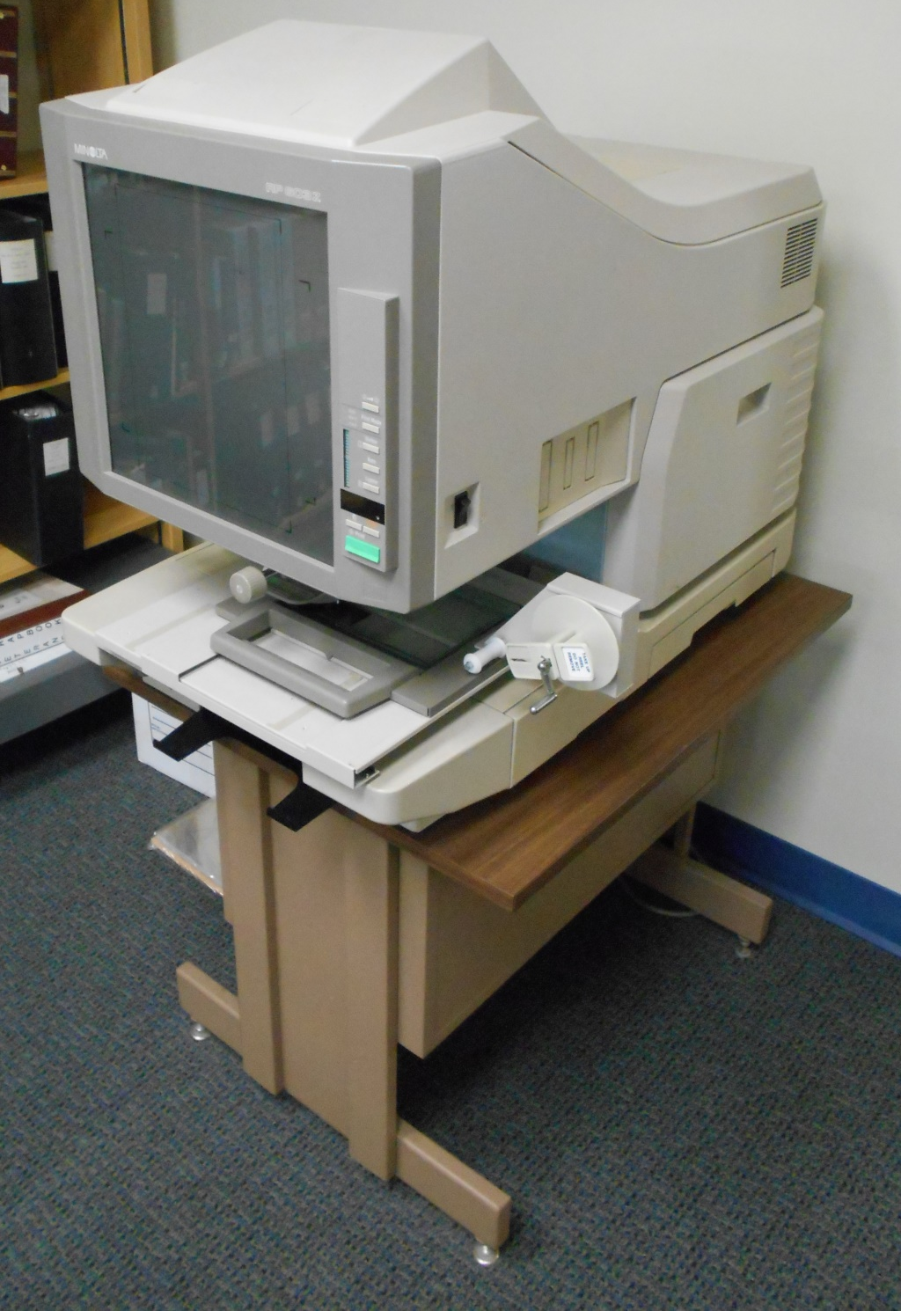
Realize your Archival Dreams with this gently used Minolta RP 603Z Microfilm and Microfiche reader!
Forward! Rewind! Pan! Zoom! Rotate! Print!
It does everything that a Microfilm reader should.
Comes with:
4 new toner cartridges + 1 in the machine
2 replacement bulbs + 1 in the machine
User’s Guide
Stand (pictured)
Approximate dimensions (LxWxH):
Machine: 23” X 34” X 29”
Stand: 24” X 30” X 24”
Originally valued at $5500, we are giving it away for FREE! Just come and get it!
Recipient must come and pick it up from:
Delta Public Library
402 Main Street
Delta, OH 43515
Questions?
Call Clint Parry
419.822.3110
cparry@oplin.org

