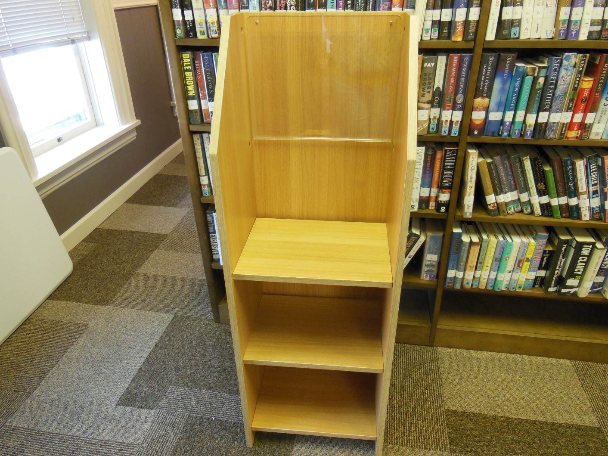
FREE TO A GOOD HOME~NEWSPAPER RACK. LIGHT HONEY OAK FINISH WITH LUCITE COPY HOLDER. MEASURES 17” W X 50” H X 14” D . DONATED NEW TO LIBRARY IN 2007. A BIT ROUGH BUT STILL VERY USABLE
MUST PICK UP AT BROWN MEMORIAL LIBRARY IN LEWISBURG
937.962.2377 X 201 FOR INFORMATION

