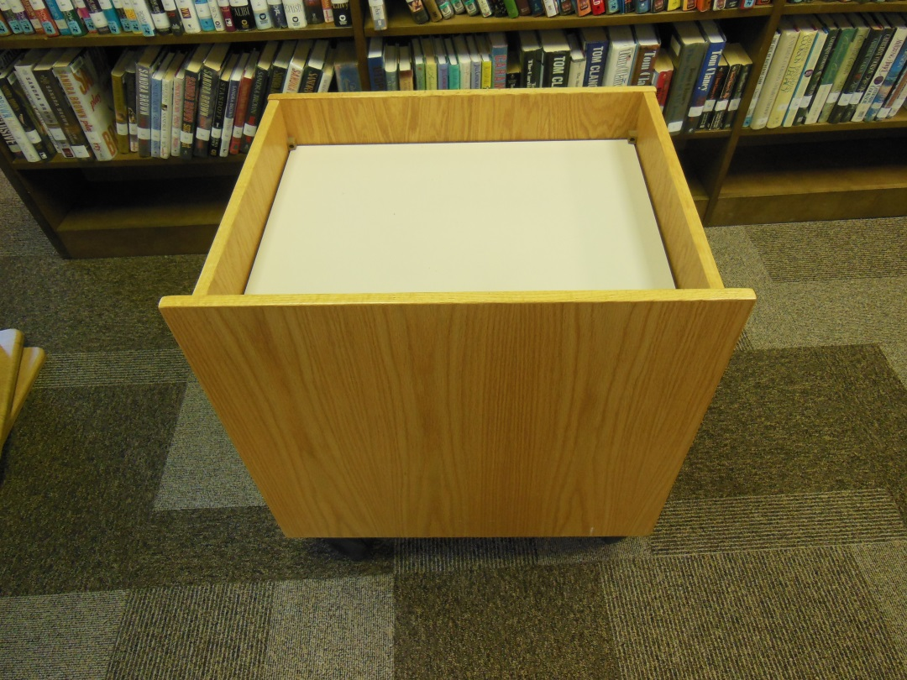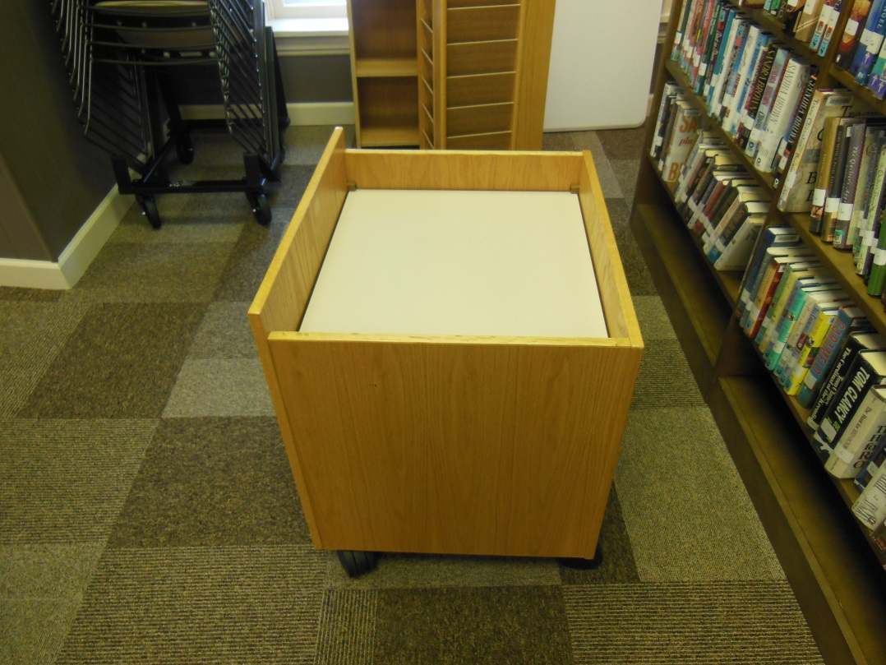
FREE TO A GOOD HOME~~STANDARD CIRC DESK-TYPE DEPRESSIBLE-BOTTOM BOOK DROP. LIGHT OAK FINISH; PURCHASED 2001 FROM WORDEN COMPANY. FOUR CASTERS; MEASURES APPROXIMATELY 22” X 26”X 22.5” H.
PICK UP AT BROWN MEMORIAL LIBRARY, 101 South Commerce Street, Lewisburg (Preble County)

