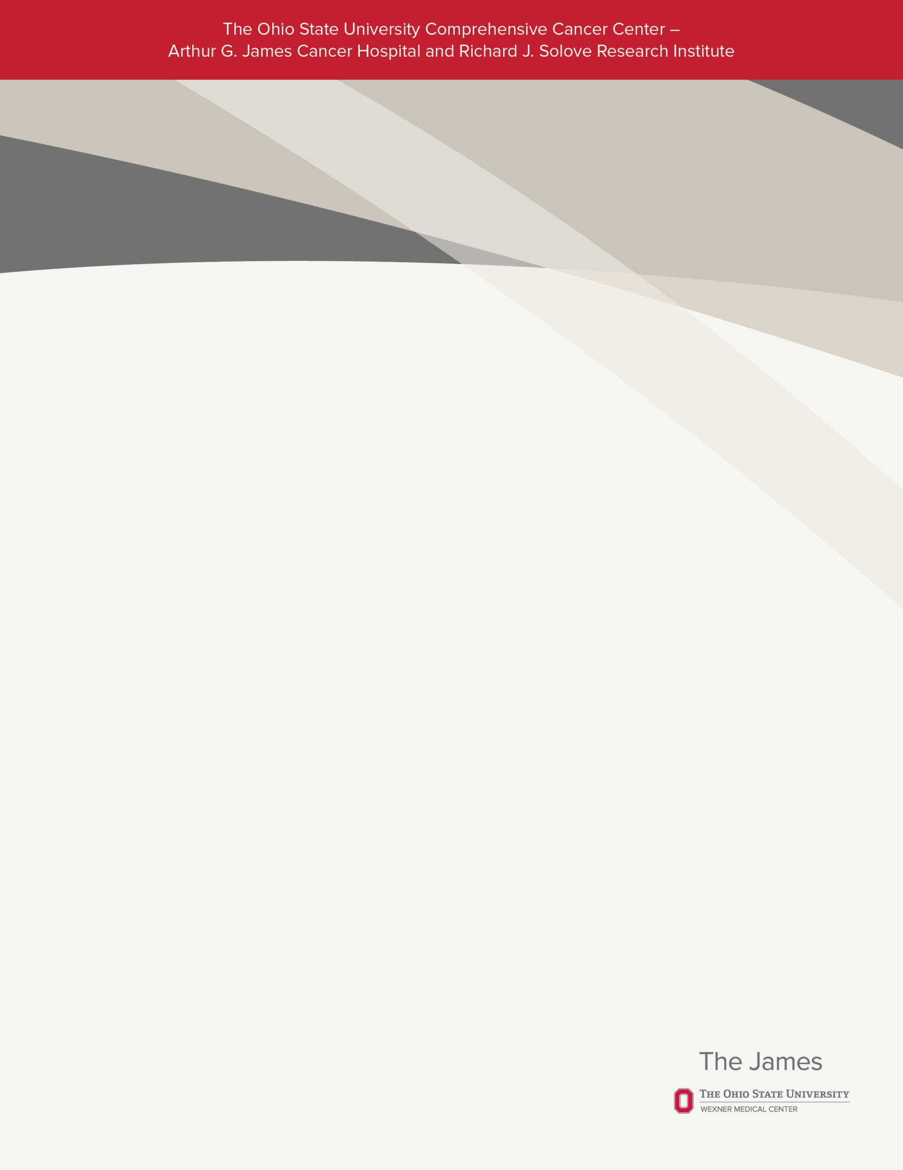

Wednesday, October 22, 2014

6:30 - 8:00 p.m.

Computer Lab #350

660 Ackerman Road

* Obtain advice from health librarian, Abigail Jones, with the Library for Health Information at the Ohio State University.
* Interactive workshop on how to search for quality health information on the internet.
* Includes step-by-step guidelines you can use to evaluate the information you find on the internet.
* Handouts with additional information will be provided to take home.

*For more information and to register, please call James*Care *for* Life *at 614-293-6428 or visit* <http://www.cancer.osu.edu/go/support>

*Free-of-charge to cancer survivors and their caregivers.*

James*Care* for *Life* presents

Healthy Web Surfing to Find Quality Health Information

Abigail Jones, MLIS, MA