- Misc. Labels – including File Folder labels in assorted colors
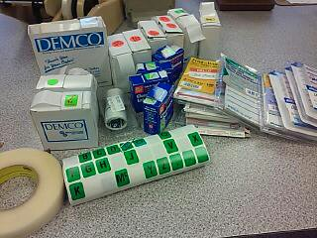
- 3M desensitizers (hand held) – USED Box of [5]
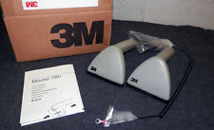
- 3m desensitizers/resensitizer (plug-in) – USED [3]
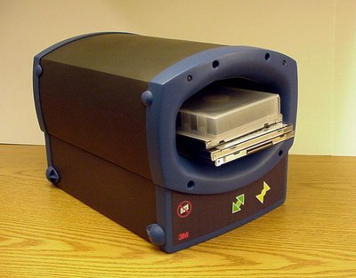
- Polyline double CD cases – NEW CSP1202C-200
Box of 180
Box of 175
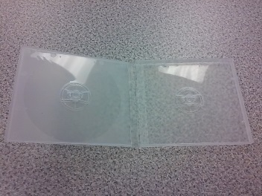

- Counter top literature/pamphlet spinner (one tip broken at top)
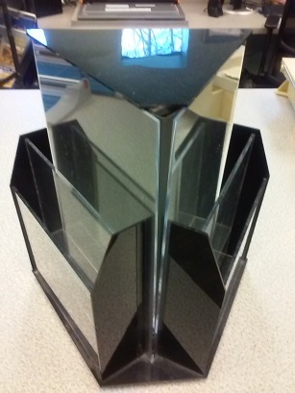

- Polyline single CD cases, NEW CSP1201C-200
Box of approx. 125
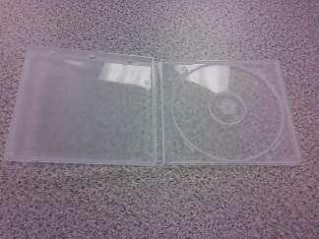

- Security locks – used for gray and blue strips USED [8]
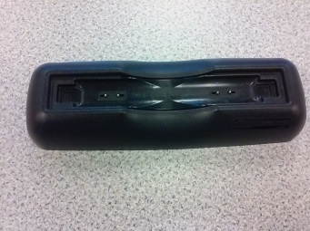
- Security locks – used with blue strips [4]
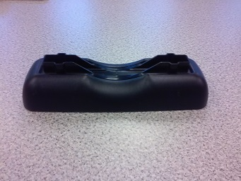
- Playaway security locks USED – Black approx. 50, [2] keys
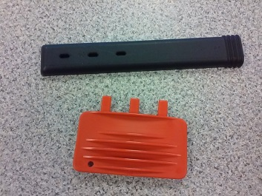
- Gray secure case security strips USED - Approx. 350
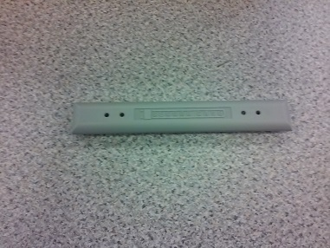

- Blue security strips
Approx. 300 New
Approx. 200 Used
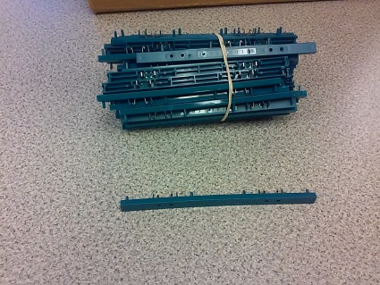

- DVD Security Cases – NEW use with Blue Strips (approx. 30)
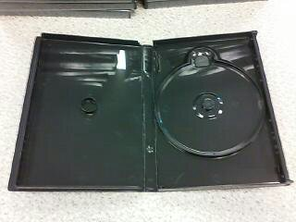

- DVD Cases – holds up to 6 discs – New (approx. 50)
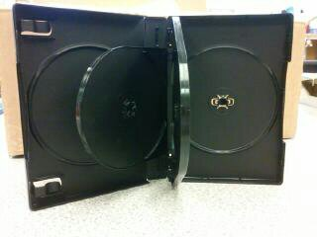
- Adaptors – NEW [4] small and [3] large
