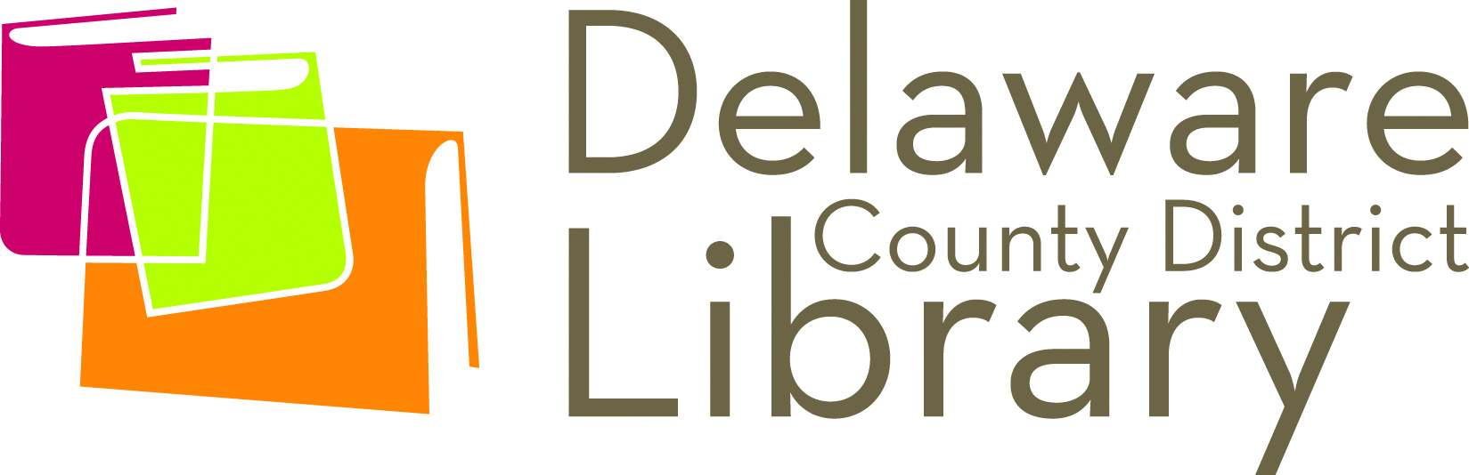
FOR IMMEDIATE RELEASE
AUTHOR CRISTINA HENRIQUEZ TO SPEAK AT DELAWARE MAIN LIBRARY OCTOBER 9
Author penned the selected DelawaREADS title “The Book of Unknown Americans”

Friday, October 02, 2015
Contact: Nicole Fowles – Communications Manager
740-362-3861 (Office) or 330-340-3702 (Cell)
nfowles@delawarelibrary.org

Delaware, OH: -- The Delaware County District Library (DCDL) welcomes New York Times recognized author Cristina Henríquez for a free after-hours speaking engagement open to the public. She will speak on Friday, October 9 at 7 p.m. at the Delaware Main Library, located at 84 E. Winter St. in Delaware.

Henríquez’s novel, The Book of Unknown Americans, was chosen as the Library’s focal point for DelawaREADS, their fall community read. Nearly 500 copies of the book were ordered and distributed to the Library’s four branches for six book groups to read and discuss.

“Our DelawaREADS committee was looking for a contemporary title that would be new to many of our patrons,” said Orange Branch Library Assistant Manager Sara Kennedy. “With all the discussion that is happening in our nation around the topic of immigration, we felt the message and the subject matter of the book was quite timely.”

The Book of Unknown Americans tells the stories of the Rivera and Toro families. The Riveras move to America from Mexico in hopes of giving their daughter Maribel, who has sustained a debilitating head injury, a better life. At their apartment complex they meet the Toros from Panama, who also have a son the same age as Maribel. For the children, it’s love at first sight. For the families, it’s the beginning of a beautiful friendship. Woven into their stories are the testimonials of men and women who have come to the United States from all over Central and Latin America.

At her visit, Henríquez will speak on the topic of “Dual Identity,” discussing her own experience of growing up half-American, half-Panamanian, and how her sense of her own identity formed and has been continually reshaping over her life. Though highly autobiographical, this is a talk that will be relevant to anyone who has ever wondered to themselves, “Who am I?”

The Book of Unknown Americans was a New York Times Notable Book of 2014 and one of Amazon’s Top 10 Books of the Year. It was the Daily Beast Novel of the Year, a Washington Post Notable Book, an NPR Great Read, and was chosen one of the best books of the year by BookPage, Oprah.com, and School Library Journal. It was also longlisted for the Andrew Carnegie Medal for Excellence in Fiction. Henríquez earned her undergraduate degree from Northwestern University and is a graduate of the Iowa Writers’ Workshop. She lives in Chicago.

Fundamentals Parent Teacher Store will provide copies of Henríquez’s book for purchase during the talk. Books may be ordered in advance by calling 740-363-0290.

Henríquez’s visit is partly funded by a grant from the National Endowment for the Humanities and the American Library Association. The Latino Americans: 500 Years of History grant is part of an NEH initiative, The Common Good: The Humanities in the Public Square.

For more information about programs and services at DCDL visit our web site at www.delawarelibrary.org or contact Nicole Fowles, Communications Manager, at nfowles@delawarelibrary.org or (740) 362-3861.

###

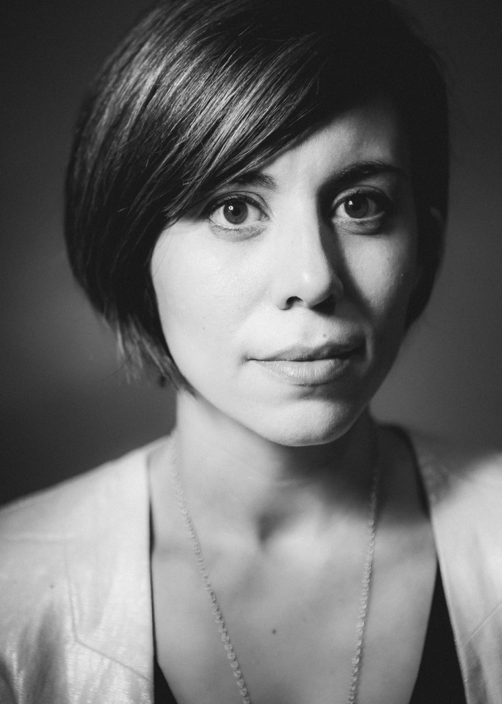

Cristina Henríquez headshot

About the National Endowment for the Humanities

Created in 1965 as an independent federal agency, the National Endowment for the Humanities supports research and learning in history, literature, philosophy and other areas of the humanities by funding selected, peer-reviewed proposals from around the nation. Additional information about the National Endowment for the Humanities and its grant programs is available at www.neh.gov.

About the American Library Association

The American Library Association is the oldest and largest library association in the world, with approximately 58,000 members in academic, public, school, government and special libraries. The mission of the American Library Association is to provide leadership for the development, promotion and improvement of library and information services and the profession of librarianship in order to enhance learning and ensure access to information for all.

