Computer tables

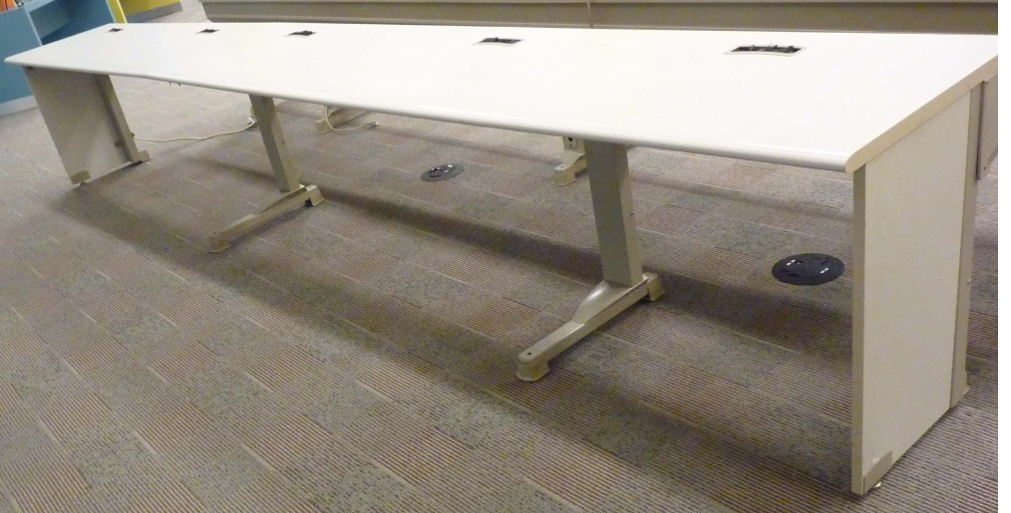

3 Each 15 Feet X 24 inches X 29.5 inches (Russ feels should sell for $1,000)
1 Each 09 Feet X 24 inches X 29.5 inches (Russ feels should sell for $600)
1 Each 12 Feet X 24 inches X 29.5 inches (Russ feels should sell for $800)
1 Each 12 Feet X 30 inches X 32.5 inches (Russ feels should sell for $800)
Total 78 Liner feet
Contents –CRN $20,865. Or $267.50 per foot
Contents – Sound $13,562. Or $174.13 per foot

Paperback Book Display, with 4 Revolving Displays
2 Ea $2,600 each Total $5,200 (Russ feels should sell for $200)
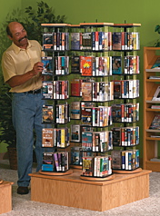 Demco Sells this New For $1,849.99
This is from an Appraisel Insurance Values done May 03, 2011 by Industrial Appraisal Company.

