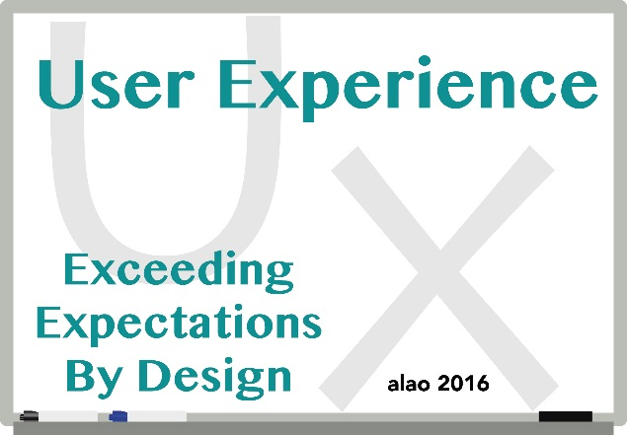

The Academic Library Association of Ohio (ALAO) will hold their 42nd Annual Conference on October 28, 2016 at Roberts Centre in Wilmington, Ohio. The Conference Planning Committee invites you to submit a poster and/or roundtable proposal on the theme: “User Experience: Exceeding Expectations By Design” which seeks to explore how academic libraries and librarians meet (and exceed) users’ needs by being innovative with resources, services, and space. Applicants are encouraged to develop proposals that show thoughtful consideration of this year’s conference theme. Share with your colleagues your ideas, experiences, solutions, and best practices – even those that yielded results that were different than expected!

The submission deadline for poster and roundtable sessions is June 24, 2016.

Presentations in poster format or roundtable discussion may include but are not limited to topics such as:
- Outreach and Marketing
- Collaboration
- Reimagining space
- Web services and design
- Usability
- Accessibility
- Discovery and Metadata
- Digital initiatives
- Institutional Repositories
- Open Access
- Evolving job responsibilities
- Instructional design
- Distance learning and Embedded librarianship
- Gamification
- Strategic planning
- Information architecture
- Emerging collection development trends
- Nontraditional resources and services
- Services for and inclusion of diverse populations
- Programming
- Makerspaces
Submission guidelines
You may submit multiple proposals, however, no more than two will be included in the final program.
.
- Submit your proposal online.
- All proposals will be blind-reviewed for content, relevance to the conference theme, and overall appeal. A concise, clearly written description (50 word limit, to be used in the conference program) and abstract (150 word limit, to be used in the blind-review process) will help the reviewers in evaluating your proposal.
- Exclude the name of your institution, department and any personal names in the abstract to expedite the blind review process. You do not need to exclude this information in the brief description intended for the conference program.
- You will be contacted regarding your AV/technology requirements if your proposal is accepted.
- All presenters are responsible for their own registration and travel costs.
- Please print a copy of the completed form for your records before submitting.
- You will receive an email confirmation upon submission. If you do not receive confirmation, or have questions about your submission, please contact Carrie Girton by email: program@alaoweb.org

Presenter grants
ALAO encourages library support staff and library student growth, career development, and participation in conference activities, and awards two presenter grants, one for support staff and the other for students. These grants (up to $150 each) are intended to assist with the costs incurred in preparing the presentation and modest travel costs associated with the presentation. Additional information will be sent to those who indicate eligibility on their submission forms.

Conference Information
Visit the conference’s webpage for more information about the conference and preconference. The site will be updated periodically.

