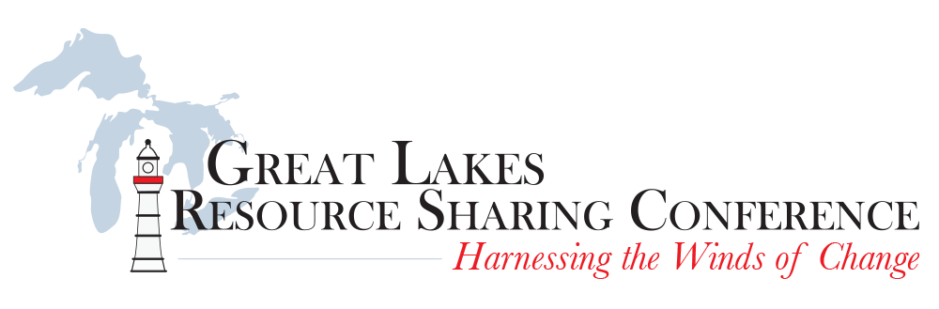
Don’t miss your chance to present at the 4th Annual Great Lakes Resource Sharing Conference, hosted at the DoubleTree by Hilton in Oak Brook, IL on June 8-9, 2017.

The deadline for submissions is fast approaching. On behalf of the GLRSC Program Committee, we encourage you to submit a proposal by January 17th to share your ideas, success stories, and lessons learned in any of the topic areas listed below.
- Resource Sharing Best Practices  - Marketing Services  - Electronic Resources and Resource Sharing  - Workflow Improvements  - Cooperative Collection Development  - Consortial or Group Purchasing  - Purchase on Demand | - Reciprocal Borrowing  - Shared Staffing and Training  - Shared Discovery Layers  - E-Books  - Resource Sharing in Next Gen Systems  - Shared Print Projects  - Open Educational Resources

Our keynote speaker for this year’s conference will be Corey Seeman, who has worked in a wide variety of environments—including time at Innovative Interfaces, the National Baseball Hall of Fame, and the University of Toledo—and has written and presented on customer service and change management in libraries. He currently serves as Director of Kresege Library Services for the Ross School of Business at the University of Michigan, Ann Arbor, where he guided its dramatic transformation from a collection of 70,000 physical volumes to one containing almost only electronic resources.

So, if you have been wrestling with changes and challenges in your library, we encourage you to submit a proposal TODAY to share your knowledge and network with colleagues working in resource sharing from all around the Great Lakes region. Proposed presentations can take the form of either a break-out session (45 minutes in length) or a lightning talk (15 minutes in length), each including time for questions.

Accepted presenters will have the opportunity to publish a version of their conference presentation to the Journal of Interlibrary Loan, Document Delivery, & Electronic Reserves in a special issue, but will not be obligated to do so. More information about this opportunity is available at http://explore.tandfonline.com/cfp/bes/jildder-cfp-glrs.

Each proposal should include a title, description, and abstract. Program proposals will be reviewed by the program committee, with selected presenters notified by February 17, 2017. Please direct any questions to Shelly Miller (shellym@ohionet.org) and Mark Sullivan (sullivm@geneseo.edu).

