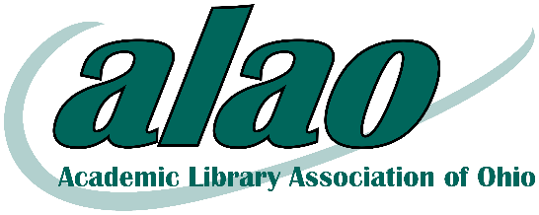
ALAO’s Instruction Interest Group’s Spring Workshop
Learning from Experience: Sharing Applied Threshold Concept Methods in Instruction
Call for Presenters
Have you begun piloting or experimenting with applications of ACRL’s new Framework for Information Literacy for Higher Education? Do you have an assignment or activity to share on a threshold concept? Do you have a fruitful collaboration with faculty in implementing the Framework at your institution? If so, the Academic Library Association of Ohio’s (ALAO) Instruction Interest group invites you to share your activities and experiences at our Spring Workshop on Thursday, April 20th at the State Library of Ohio.
ALAO's Instruction Interest Group (IIG) is looking for presenters who have designed and taught library assignments or activities that teach any of the six threshold concepts. Do you have fresh ideas you’d like to present? Now’s your chance!
We are interested in breakout sessions that offer insights in any of the following topics:
- Adapting or creating new assignments or activities
- One-shot instruction and the new Framework
- Practical applications of the Framework
- Setting learning outcomes
- Best practices and discoveries
- Finding common ground between the old Standards and new Framework
- Collaboration with Faculty
- Curriculum mapping
- Online learning modules/tutorials
The deadline for proposals for is Feb. 15, 2017. To submit your idea, please click on the following link and fill out the form: https://goo.gl/forms/5nylQF3nUW6hYU1d2. Session proposals will be reviewed by the IIG planning committee. We’d especially love sessions that include audience participation.
Please e-mail any questions to IIG Co-Chairs Dana Knott (dknott@cscc.edu) and Mark Eddy (mxe37@case.edu).

