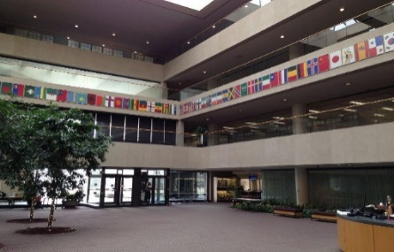
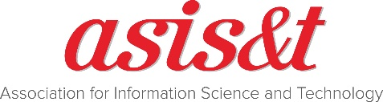

OHIO REGIONAL MEETING
March 3, 2017
OCLC Conference Center, Dublin, Ohio

This meeting is being hosted by ASIS&T, Central Ohio Chapter and the Northern Ohio Chapter.
Program & Schedule
8:30-9:00am | Arrival, check-in and social
9:00-9:15am | Introduction & Welcome by ASIS&T President Lynn Silipigni Connnaway
9:15-9:45am | Developing Services to Support New Needs: Academic Librarians’ Experiences with Research Data Management Programs , Ixchel Faniel
9:45-10:15am | Evolving Support for Research Information Management, Rebecca Bryant
10:15-10:30am | Coffee Break
10:30-11:30am | The Library in the Life of the User, Lynn Silipigni Connaway
11:30-12:30pm | Library Linked Data: Where Things Stand, Jean Godby
12:30- Lunch
1:30pm
Afternoon Workshops (choose one)
3:30- Afternoon Coffee Break
3:45pm
1:30-5:00pm | Visitors and Residents Interactive Mapping Exercise Workshop, Lynn Silipigni Connaway and William Harvey
1:30-5:00pm | Taxonomy Workshop, Joseph Busch
5:15-5:45pm | 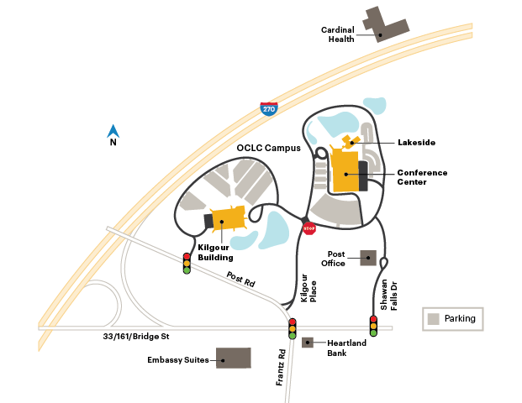  Tour of OCLC Facility (Kilgour Building)

Inclement weather alternative date: April 28, 2017

Registration Rates
$60 – Members
$80 – Non-Members
$35 – Students
Registration includes breaks, lunch and facility tour

Make Reservations at an area hotel

Thank our sponsors!!
