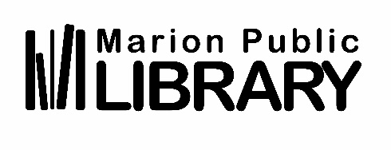
Position Title: Associate
Department: Youth Services
Immediate Supervisor: Youth Services Manager
Pay Grade: 17 ($15.50 – $20.26)

Minimum Qualifications: Bachelor’s degree
Minimum 2 years of experience working with kids or young adults
Previous customer service experience mandatory.
Evenings and weekends regularly scheduled.
Valid Driver’s License and personal vehicle.

Position Description: Assisting patrons of all ages with an emphasis on kids, teens, and families. This position is full time and will be scheduled at all public service desks including the Kid’s area, main desk, and information desk as needed.

Essential Duties and Responsibilities:
- Proactively provides customer service and assistance to library users including Readers’ Advisory, reference services, account maintenance, and general help with library computers and digital collections.
- Straightening, stocking displays, and overall maintenance of public areas, including shelving as needed.
- Assists supervisor with projects as assigned.
- Assist in implementing programming for all ages, including storytimes.
- Ability to positively represent library services at outreach events including school literacy nights, class visits, or events such as the county fair.
- Maintains up-to-date knowledge of books, libraries, and the publishing world.
- Other duties as assigned.

Required Abilities:
- Must have excellent people skills and be able to assist patrons, and collaborate with staff in a patient friendly manner.
- Must be proficient with basic computer use, email communication, and enthusiastically learn systems and equipment used in daily library function.
- Manipulates library materials up to 50 pounds.
- Maneuvers loaded book carts over carpeted floors
- Follows oral and written instructions
- The ideal candidate is upbeat and enthusiastic with a passion for connecting with people of all ages.

NOTE: This position description is not intended to be a complete list of all responsibilities, skills or working conditions associated with this position and is subject to review and change at any time in accordance with the needs of the Marion Public Library. Reasonable accommodations may be made to enable someone with a qualifying disability to perform the essential functions of the position.

Employee Acknowledgement:

I have read and understand this position description.

_________________________________________ _________________
Employee Date

