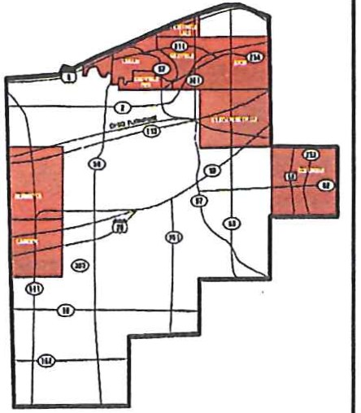
The Lorain Public Library System, or LPLS, is the largest, most comprehensive library
system in Lorain County, Ohio, with much of its service area comprising the northeast part of the county. The estimated population in the library
system's service district is over 135,000. It serves both large and small communities, boasting a diverse patronage consisting of various economic, ethnic and educational backgrounds, with our Main Branch sitting in the heart of downtown Lorain, the International City.

Library services are provided from six branches in Lorain, Avon, Columbia Station, North Ridgeville and Sheffield Lake. Additionally, LPLS has Outreach Serviceswhich include a Books by Mail program and an extensive array of e-Services available on our website.

School districts in the service area include Lorain City Schools, Avon Local Schools, Clearview Local Schools, Columbia Local Schools, Firelands Local Schools, North Ridgeville City Schools and Sheffield-Sheffield Lake City Schools.

Our communities are vibrant and diverse, our libraries world class. We are looking for dynamic individuals to be pati of our team. Comejoin us!
NORTH RIDGEVILLE BRANCH
35700 Bainbridge Road • North Ridgeville, OH 44039
440-327 -8326
SOUTH LORAIN BRANCH
2121 Homewood Drive • Lorain, OH 44055
440-277 -5672
www.lorainpubliclibrary.org
The Lorain Public Library System is seeking qualified applicants for the position of Chief Fiscal Officer.

LPLS Board of Trustees
Timetable for CFO Position
The Lorain Public Library System (LPLS) is seeking an outstanding

Garalynn Tomas, President Gloria Badillo, Vice-President Ethel Schiemann, Secretary Milagros Torres
Keith Belanger Monica Snipes Tiffany McClelland
Launch Search Application Deadline Interviews Begin Action to Employ Employment Begins
March 11
April 15
April 22 May l6 Negotiated
individual for the position of Chief Fiscal Officer. The Board of
Trustees is looldng forward to hiring a CFO who will bring to the position the highest standards of professionalism, education, integrity, transparency and commitment. The successful candidate is expected to work collaboratively with the Board, the Chief Executive Officer
and the leadership team of LPLS in furtherance of the library's goals. In addition to overseeing the day-to-day financial operations of the libra1y system, it is the CFO's responsibility to advise the Board and

Appl ication Process: Please complete an online application and forward your resume, cover letter, salary history
and three professional references ·1:0:
Lorain Public Library System
Board of Trustees c/o Michael F. Diamond Director of Human Resources
351 W. Sixth Street Lorain, OH 44052

lPLS Financial Information

Total Valuation $2,892,207,430

Millage | Outside | Levy | Revenue | Rollback and  Homestead Total
Lorain CSD | 5.95 | 2,999,284 | 359,914 | 3,359,198
North Ridgeville City | 1.91 | 1,188,894 | 180,000 | 1,368,894
Columbia Township | 1.74 | 334,834 | 48,000 | 382,834
Sheffield Lake City | 2.95 | 391,024 | 48,000 | 439,024
Avon City | 1.2 | 420,000 | 51,574 | 471,574
Appropriations
General Fund | 16,771,007
Total - All Funds | 17,556,161
Population of Service Area (2010 Census); 135,000+
Number ofEmployees (as of March 1, 2019); Full Time 61 Part Time 67
the CEO on all financial matters including providing timely reports on LPLS's current financial situation, forecasting and analysis of various funding options. The Board of Trustees expects the CFO to provide a leadership role and represent the library system in all financial matters including with local government officials.

Qualifications

Bachelor's degree from an accredited university in accounting, finance or business-related discipline
5 years progressively responsible experience in public finance or at the local government level
3 years supervisory and management experience
Applicants must have 5 years of experience in accounting, budget preparation, technical report wiiting, computer expertise and complex problem solving and decision maldng sldlls
Ability to interact with public, vendors and staff in a consistent, friendly and professional manne1'
Ability to serve as a contributing member of the senior management team and form a strong, collaborative partnership with both the Board and the CEO
Person of integrity with high standards of honesty and ethics

