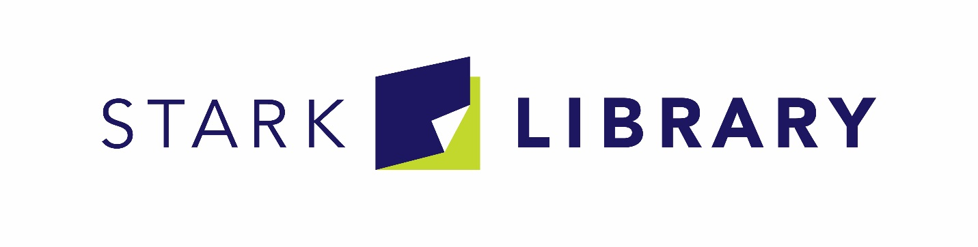
Job Posting: Library Clerk
Title: | Library Clerk
Internal Classification: | FLSA non-exempt, bargaining unit
Primary Location: | North Branch
Hours: | Part-time (20 hours/week)
Starting Hourly Rate: | $10.00 an hour

Posted on December 26, 2019. Applications for the position will be accepted for a minimum of 10 calendar days from the original date of posting.

The Stark Library seeks an outgoing, customer service oriented library professional to fill an opportunity as a Clerk at the North Branch. The Clerk position is responsible for providing excellent, frontline customer service at a variety of service points, including such things as recommending materials and services to patrons, assisting with express check, and providing technology help.

In our service model, Clerks are often on the move and interfacing with patrons. A successful candidate may have previous library or even retail experience that meets our customer-focused expectations. Additionally, the candidate should demonstrate a passion for our mission and providing library services to the diversity of patrons we serve on a daily basis.

The Clerk position has an hourly wage rate of $10.00, and eligibility for a benefit package following sixty days of employment.
If you want to work for a mission-driven organization and believe you may be a good fit for this position (detailed job description, below), please go to Stark Library website - www.starklibrary.org - for more information and to complete an employment application. Go to “Contact” and then “Employment” for access to our on-line application.

About Stark Library
Stark Library serves over 118,707 active cardholders, annually circulating 4 million items from its 1.7 million item collection and providing access to an additional 61 million items from lending networks throughout Ohio. Each year the library presents more than 8,000 programs for 150,000 attendees and provides 200,000 computer sessions on the publicly available computers found in each branch. The system consists of ten branches, including our main library, as well as a mobile services department.
Position Summary
An employee serving in this position advances the mission of the Library by providing direct public service. This role is responsible for performing clerical work related to customer assistance and services, circulation, and the collections as well as providing support to other Library staff as needed.

Duties and Responsibilities
Customer Assistance
- Is typically the initial point of contact for most patrons/customers and spends majority of time providing customer assistance “on the floor”.
- Promotes library services and offerings to patrons.
- Introduces patrons to all library service and collection platforms, and can demonstrate their basic functionality.
- Performs basic searches in Library catalogs through both public and ILS interfaces.
- Assists patrons with basic informational questions using common internet search techniques or prepared reference resources.
- Is aware of and can direct patrons to print and online reference tools, including Reader’s Advisory resources.
- Assists patrons in accessing and using document machines, library computers and library-supported software, and troubleshoots common technical problems.
- Performs transactional services (e.g., notary, passport) that have defined rules, limited or specific answers, and/or detailed process guidelines.
Circulation
- Performs all direct patron and material circulation functions.
- May assist with record maintenance tasks.

Group Services: Internal and External
- Assists other staff with internal and external group program set up.
- Introduces patrons to internal, passive programs and related materials.
- May assist other staff with preparing materials for programs.
- May assist other staff in external promotional activities.
General
- May assist in shelving as needed.
- Assists in merchandising materials.
- Pulls materials from a list to assist with collection management or circulation tasks.
- May assist with training staff members
- Serves on library committees as needed.
- Performs other duties as required.

Core Competencies
- Adaptability  - Communication  - Customer Service  - Dependability  - Ethics & Integrity | - Initiative  - Job Knowledge  - Quality of Work  - Teamwork
Technical / Functional Skills
- Basic familiarity with library services and operations.
- Ability to perform basic circulation and service functions using the library circulation system, service platforms, and following current procedures.
- Ability to master basic functionality of collection platforms.
- Ability to learn and obtain certification in passport processing.
- Demonstrates basic to intermediate level literacy with respect to standard computer and office software.
- Ability to sort and file alphabetically and numerically.
- Ability to communicate effectively in the English language by phone or in person in a one-to-one setting.
- Ability to make simple arithmetic calculations with speed and accuracy.

Education and Experience
- Education: High school diploma or equivalent is required.
- Years of relevant experience: 0 to 2 years is preferred.
- Experience with the principles and practices of customer service is preferred.
- Experience with library circulation systems and procedures is preferred.
- Experience in public library or public-sector organizations is preferred.

Working Conditions and Physical Requirements
- The library environment involves everyday risks or discomforts that require normal safety precautions typical of offices, which includes the need for general safe workplace practices with office equipment and computers, avoidance of trips and falls, and observance of fire regulations. When this position is within the Mobiles Services department work performed on vehicles (e.g., bookmobiles) is done in close quarters that, at times, may be in motion as teams travel from stop to stop. Additionally, this work is done year-round in vehicles furnished with heat and air conditioning.
- The noise level in the work environment is usually quiet to moderate.
- This position is performed mainly in the public and office areas of the Library although some off-site meetings in various other locations may occur (e.g., school visits, etc.). When this position is within the Mobile Services department it is performed mainly in the mobile services vehicles as well as public and office areas of the Library although some off-site meetings in various other locations may occur.
- Work is generally completed during Library days and hours of operations which may vary by location and time of year. There may be the occasional need to attend meetings or events and/or respond to critical situations outside of this schedule, including before or after normal Library days and hours of operation.
- Work requires the ability to lift light objects [less than 20 pounds] and carry them short distances [20 feet or less] and, within Mobile Services particularly, load/unload materials and equipment in all weather conditions.
- Work requires the ability to push a fully loaded book cart (typically weighing at least 20lbs or more) for distances of at least 20 feet.
- This position may require an employee to remain in a standing or seated position for extended periods of time while performing a variety of tasks.
- Employees must be able to perform repetitive hand, arm, and body movements, including typing and/or lifting books, on a continuous basis.
- Work requires reaching overhead and bending/kneeling to shelve books weighing up to three pounds.
- Travel by personal automobile or, in the case of Mobile Services positions a Library-owned automobile or truck, and a valid State of Ohio driver’s license along with the ability to maintain a driving record that is satisfactory to the Library’s liability insurance carrier may be required, depending on the position’s specific duties. Some travel by personal vehicle and/or occasional overnight travel may also be required.
The intent of this position description is to provide a representative summary of the major duties and responsibilities performed by an individual working in this job. Employees may be requested to perform job-related tasks other than those specifically presented in this description.

