Hello friends,

Last year, a group of state-wide, library-focused organizations worked together to create a day of discussion and networking for library staff from all types of institutions. The result was Re-IMAGEing Ohio’s Libraries—held at The Conference at OCLC on June 14th. The goal of this event was to create connections and foster conversations across different types of libraries that would raise awareness of common issues and encourage collaboration in their local communities. Attendees to that event had the opportunity to learn what other types of libraries are doing and explore mutual benefits across different types of libraries.

However, one day of great discussions is just the start. We are excited to continue these important cross-type interactions in communities around the state with a series of free, informal meetings to be scheduled over the next few months called Continue the Conversations. Each meeting is being organized by area volunteers and will include a facilitated discussion focused on generating ideas and building inter-library networks.

All are welcome, even if you weren't able to attend the first event last summer.

Mark your calendar and plan to join your area colleagues at the Mansfield/Richland County Public Library on Friday April 3 beginning at 9:30 am. Bring your stories, ideas, and suggestions. Please click the following link to register for this FREE event:

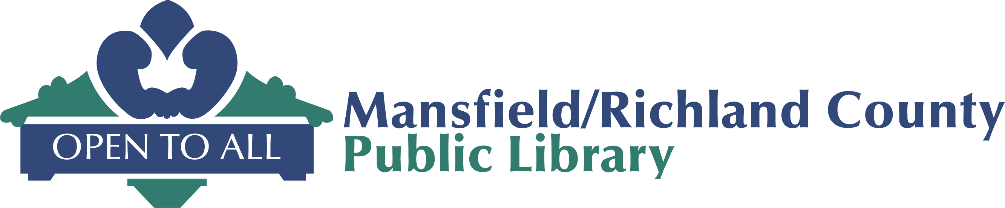
Register Here

www.mrcpl.org

MAIN LIBRARY
43 West Third St.
Mansfield, OH 44902

Hope to see you there.

Sincerely,

Deborah Dubois, Stephen Russell, Anne Rhodes
Northeast Ohio Organizers

