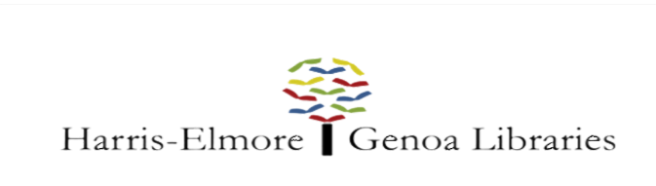 Outreach Storytime Specialist

Classification | Outreach Storytime Specialist | FLSA Status | Non-Exempt
Level | Part Time | Division | Harris-Elmore & Genoa
Reports to | Director; Asst. Director; Br. Mngr.; Programs Librarian | Schedule | 30 hours per month.  TBD Weekly.
Salary Range | $15.40 hourly | Date Revised | February 2020

JOB RESPONSIBILITIES

Under the general direction of the Director, Asst. Director, Branch Manager or Programs Librarian, the Outreach Storytime Specialist will conduct library storytimes and literacy programming at area schools for both the Elmore & Genoa communities. This position directly serves pre-school and grade school children through story-telling, music and songs, and engaging in learning activities. This position requires an understanding of early literacy and its importance to future academic success.

PRIMARY DUTIES

- Plan high quality, engaging storytimes and literacy activities for a wide age-range of children.
- Meet on a monthly basis with the Director and Branch Manager to go over planned storytime activities and strategies.
- Lead 2 library storytimes weekly (3 during summer) and 4-6 storytimes/literacy activities monthly at the Genoa & Elmore Schools and daycare centers.
- Prepares all items needed for Storytimes & Outreach Activities (ie: Snacks, Crafts, etc.)
- Chooses appropriate and engaging read aloud stories and develops age appropriate extension activities.
- Engages and interacts with children and other community members at designated locations.
- Drives to off-site locations to present programs.
- Provide a warm, fun, and safe atmosphere for all children and their families.
- Works to build authentic relationships with parents/teachers to learn how best to encourage efforts to support child learning and to seek their input for future programming.
- Provide relevant resources to families and teachers as needed.
- Assists in promoting library programming among children and families/teachers at each site.
- Attends and participates in professional library conferences, webinars, seminars, or other continued education opportunities (2 required per year);
- Attends and participates in staff meeting discussions. Attendance is required at staff meetings with the following exceptions: illness, vacation where vacation time is used, scheduled training/conference, or scheduled shift at another place of employment. Having the day off is not an excused absence. Approved absences to be approved by the director.
- Required to wear name tag identification during work hours.
- Participates in local events (festivals, fairs, expos, etc.) to promote library services. Attendance is required for at least one event annually.
- Performs other related work as required

SKILLS & ABILITIES

- Understands and follows written and oral instructions.
- Knowledge of early childhood and childhood literacy.
- Ability to prepare, lead, and implement engaging literacy-rich programming for children of various ages.
- Dependability, flexibility, and very strong interpersonal skills.
- Ability to communicate effectively with others, orally and in writing, including through email.
- Ability to establish and maintain effective working relationships with co-workers.
- Enthusiasm for teamwork and collaboration.
- Ability to recognize and set priorities, and to use initiative and independent judgment in a variety of situations.
- Must be able to lift, push, or carry bags of books or boxes weighing up to 25 pounds.
- Must be able to drive a car and hold a valid driver’s license. Mileage is reimbursed.
- Ability to attend occasional training and other library related events as assigned.
- Must possess physical mobility involving bending, lifting, reading, and hearing.
- Ability to maintain a positive attitude of customer service to the public, even under trying circumstances.

EDUCATION/QUALIFICATIONS

- High School Diploma or GED equivalency
- Teaching Experience Preferred
- Bachelor’s Degree or equivalent combination of education and experience which provide the skills needed for effective job performance preferred.

Please send a resume and three references to:

Jennifer Fording, Director
Harris-Elmore Public Library
director@harriselmorelibrary.org

