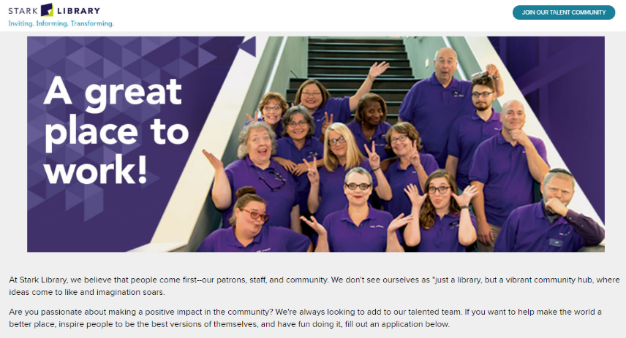
Librarian (with youth focus)
Stark County District Library
Full Time
Canton, OH, US

Title: | Librarian (with youth focus)
Internal Classification: | BU6 (FLSA non-exempt)
Primary Location: | Perry-Sippo Branch
Hours: | Full-time (40 hours/week)
Hourly Rate: | $17.78
Posted 4.27.2021
Stark Library is seeking an outgoing, customer service oriented professional to fill an opportunity as a Librarian with a focus on supporting our youngest patrons (ages birth through teens) at our Perry Sippo Branch.
This position is responsible for designing and implementing programming for ages birth-18, working collaboratively with a Library Specialist responsible for part of the youth programming. Successful candidates will have proven knowledge of and experience with collection materials and outreach services suited for the needs of the youth in our service area.
Stark Library's Perry-Sippo Branch is an active environment and candidates should enjoy working with the public and be able to demonstrate a strong customer orientation that supports our mission and service to the diversity of the communities in which we operate.
If you want to work for a mission-driven organization and believe you may be a good fit for this position (detailed job description, below), If you believe you may be a good fit for this position, please go to the Employment section of our website and complete an employment.

Position Summary
An employee serving in this position advances the mission of the Library by serving as a professional librarian, providing direct public service, programming, outreach, and collection management services and expertise. This role is primarily responsible for providing leadership in a designated area/age group per the needs of the department or location. The Librarian is also responsible for establishing and maintaining key external relationships (e.g., authors, publishers, organizations, etc.) on behalf of his/her location or department and representing the Library in various outreach capacities. The Librarian, in conjunction with the Department or Branch Manager, helps set location goals for their own work as well as that of the rest of the staff and helps lead system-wide projects.
Duties and Responsibilities
Customer Assistance
- Demonstrates and assists patrons with all library service and collection platforms, and is an advanced user of platforms.
- Provides instruction on platforms in area of specialization.
- Performs advanced searches through both public and ILS interfaces. Contributes to improving access for other staff in area of specialization.
- Demonstrates and assists patrons with print and online reference tools, including Reader’s Advisory resources.
- Assists patrons in accessing and using document machines, library computers and library-supported software, and troubleshoots intermediate technical problems. Provides advanced assistance in area of specialization.
- Provides advanced reference assistance, and helps develop access tools in area of specialization.
Individual Services
- Performs transactional services (e.g., notary, passport)
- Facilitates special support and services that include open-ended interactions requiring analysis, additional data gathering, independent judgment/decision-making and may have multiple “right” answers or possible outcomes (e.g., Book an Expert)
Circulation
- Performs all direct patron circulation functions.
- May have responsibility for regularly implementing record maintenance tasks.
- May have in-depth understanding of ILS Circulation Module, and may troubleshoot ILS issues.
- May troubleshoot and resolve complex patron account issues, in consultation with Manager.
Collection
- May assist in shelving as needed.
- Plans merchandising and organization of designated collections area(s).
- Manages assigned collection areas and works in coordination with Manager and other staff in all aspects of collection merchandising and maintenance.
- Creates Educator Units as needed and may provide direction to other staff who assist with creating Educator Units.
Group Services: Internal and External
- Leads or assists other staff with internal and external group program set up.
- Plans and/or presents internal and external programs.
- Participates in and may lead promotional activities outside the library.
- Develops content and materials for both active and passive delivery to groups. May sometimes involve other staff, as needed.
- Plans and provides guidance to other staff on the general direction of services/programs for given focus area(s).
Partnerships
- Establishes partnerships, develops content for, and implements joint services with outside agencies on behalf of his/her department, location, and the system.
General
- Mentors and trains other staff, including Specialists and Librarians in other locations.
- Leads, system-wide planning, development and training initiatives.
- Provides functional guidance to other staff regarding services, programs, and collections within area(s) of expertise.
- Serves on library committees as needed.
- Performs other duties as required.

Technical / Functional Skills
- Ability to plan, develop, implement and promote library-related programs.
- Ability to provide specialized, open-ended customer service support in one or more areas without assistance from other staff.
- Ability to create Educator Units.
- Advanced familiarity with library services and operations.
- Ability to perform intermediate to advanced functions using the library circulation system, service platforms, and following current procedures.
- Advanced knowledge of collection platforms.
- Ability to learn and obtain certification in passport processing.
- Demonstrates intermediate to advanced level literacy with respect to standard computer and office software.
- Ability to sort and file alphabetically and numerically.
- Ability to communicate effectively in the English language by phone or in person in a one-to-one setting.
- Ability to make simple arithmetic calculations with speed and accuracy.
- Ability to assist with the training of other staff.
Education and Experience
- Education: MLIS degree required. Within the Genealogy Department a Bachelor’s degree or equivalent is required and an MLIS is preferred.
- Years of relevant experience: 3 or more years of related experience is preferred. Within the Genealogy Department, 5 years or more of related experience is preferred in the absence of an MLIS.
- Certifications or licensure: Ohio drivers’ license and ability to maintain a driving record that is satisfactory to the Library’s liability insurance carrier is required.
- In-depth knowledge of collection materials and professional resources related to focus age group is required.
- Experience working with focus age group is required.
- Experience presenting and implementing programs to groups is required.
- Experience developing programs for individuals and groups is preferred.
- Experience coordinating with external partners is preferred.
- Experience with the principles and practices of customer service is required.
- Experience with library circulation systems and procedures is required.
- Experience in public library or public-sector organizations is required.
Working Conditions and Physical Requirements
- The library environment involves everyday risks or discomforts that require normal safety precautions typical of offices, which includes the need for general safe workplace practices with office equipment and computers, avoidance of trips and falls, and observance of fire regulations.
- The noise level in the work environment is usually quiet to moderate.
- This position is performed mainly in the public and office areas of the Library although some off-site meetings in various other locations may occur (e.g., school visits, etc.).
- Work is generally completed during Library days and hours of operations which may vary by location and time of year. There may be the occasional need to attend meetings or events and/or respond to critical situations outside of this schedule, including before or after normal Library days and hours of operation.
- Work requires the ability to lift light objects [less than 20 pounds] and carry them short distances [20 feet or less] and, within Mobile Services particularly, load/unload materials and equipment in all weather conditions.
- Work requires the ability to push a fully loaded book cart (typically weighing at least 20lbs or more) for distances of at least 20 feet.
- This position may require an employee to remain in a standing or seated position for extended periods of time while performing a variety of tasks.
- Employees must be able to perform repetitive hand, arm, and body movements, including typing and/or lifting books, on a continuous basis.
- Work requires reaching overhead and bending/kneeling to shelve books weighing up to three pounds.
- Travel by personal automobile or, in the case of Mobile Services positions a Library-owned automobile or truck, and a valid State of Ohio driver’s license along with the ability to maintain a driving record that is satisfactory to the Library’s liability insurance carrier may be required, depending on the position’s specific duties. Some travel by personal vehicle and/or occasional overnight travel may also be required.

