STATEWIDE DELIVERY UPDATE
Beginning July 1, 2021 STAT Courier will be the delivery service for all libraries that participate in the statewide delivery service.

Following the following material handling and shipping guidelines will enable a faster transition of items between libraries with less damage and loss of materials.

STAT Courier will provide libraries with plastic totes.
All canvas bags are to be placed inside the totes.
Totes will be stacked in delivery vehicles and returned to hubs for sorting.

Material Handling Reminders
PLEASE TREAT ALL MATERIALS WITH RESPECT!

Notes for staff
Use only removable post-it notes when alerting staff of special instructions on items.

Rubber bands
Use properly sized rubber bands.
Do not roll up items with rubber bands that are too tight!
Use rubber bands when securing padded mailers.

DVDs, CDs and Books on CDs/Tapes
To help reduce the risk of losing materials, always open DVD, CD and Book on CD/Tape cases check the number of items that are expected to be included.

Condition of Materials
Always check the condition of items before sending them out to fill holds. No one wants to read books with stains or pages missing or try to watch a DVD that’s cracked or has scratches.

Missing Material
If a case is missing material, contact the library where the item was previously
checked out.

PLEASE DO NOT USE
 | 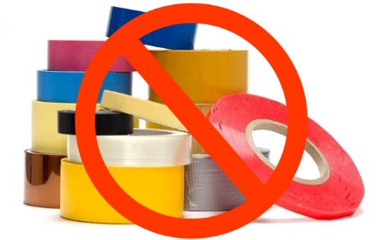 | 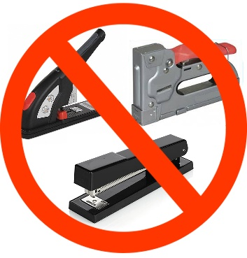
PLEASE DO NOT USE  CARDBOARD BOXES | PLEASE DO NOT USE  TAPE | PLEASE DO NOT USE  STAPLES

Please email Jamie Pardee at State Library of Ohio, jpardee@library.ohio.gov with any questions.

