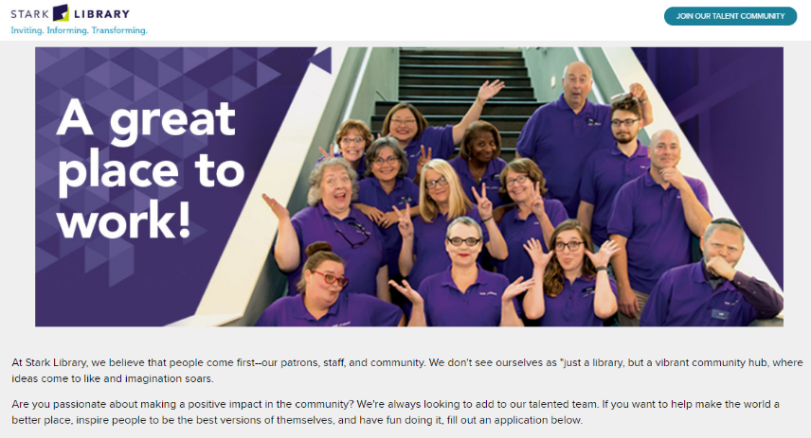
Main Library Manager
Requisition ID: 1033

Title: | Main Library Manager
Internal Classification: | Manager (E4)
Primary Location: | Main Library
Hours: | Full-time (40 hours/week)
Minimum of E4 Salary Range: | $52,000
Posted on July 9, 2021.
Stark Library, based in Canton, Ohio, is seeking a service-oriented and energetic leader to fill our Main Library Manager position.
The manager of Main Library is responsible for overseeing all staffing, operations, services, programs, and collection management at the location, in addition to managing outreach and promotion of the library to the surrounding community. This location serves as our system's headquarters and includes specialized services such as our Maker Space studio, genealogy, and a dedicated youth services department area. It is a very active, urban location that is situated just north of the immediate downtown area of Canton, including the new Centennial Plaza. Successful candidates will have a strong customer service orientation as well as experience and familiarity with managing services and staff, including other managers, in a public service environment.
This is a full-time (40 hours/week), exempt, managerial position, reporting to the Senior Director of Public Services. Compensation includes a competitive salary commensurate with the candidate’s qualifications and a generous benefits package.
If you believe you may be a good fit for this position, please complete an employment application and submit a current resume.

Position Description
An employee serving in this position advances the mission of the Library by supervising the operation of a branch library, including directing the work of all levels of staff performing technical, administrative, and clerical assignments. This employee is accountable to a library director, with whom he or she collaborates, plans and reviews plans, budgets, programs, reports and conferences. This Branch Manager supervises the full range of public library services, and is responsible for modeling outstanding customer service.
Essential Duties and Responsibilities
- Demonstrates superior seamless customer service, integrity, and commitment to innovation, efficiency, and fiscally responsible activity;
- Demonstrates commitment to service, trust, accountability, and respect in all interactions with customers, community residents, and colleagues;
- Formulates goals, plans, and procedures for a small branch library or a department of the Main Library or a system-wide department;
- Directs and coordinates the activities of the branch or department, oversees scheduling to ensure coverage of service points, and accepts responsibility for the overall operating effectiveness of the branch or department;
- Monitors and evaluates the work of the staff members of the branch or department;
- Manages the performance of assigned staff members, and holds them accountable for providing exemplary customer service consistent with Library policies and procedures;
- Seeks information from users and potential users of information and library materials about their library needs and interests;
- Answers reference questions and performs readers advisory services;
- Formulates goals, plans, and procedures and accepts responsibility for the overall effectiveness of one or more of the system-wide library support programs;
- Participates in library committee work by chairing meetings or contributing as a member;
- Represents the library in the community by making presentations and serving on boards and committees;
- Actively seeks opportunities to promote the Library with the goal of increasing public use of programs and resources, and enhancing the Library’s visibility as a vital community partner;
- Resolves customer problems;
- Participates in the interview or selection process for library staff;
- Interprets and explains library policies, objectives, and services to community groups, business and educational leaders, publishing agency representatives, and the general public;
- Maintains regular and reliable attendance; and
- Works more than forty hours in a workweek without additional compensation to perform assigned job duties.
Minimum Qualifications
A master’s degree in library science from an American Library Association (ALA) accredited institution with at least three years of experience in professional library work, with 1-2 years of supervisory experience are required.

