Kent Free Library
Surplus Furnishings Available
October 27, 2021

Item 1: Steelcase Turnstone Chairs, Green (5 available)

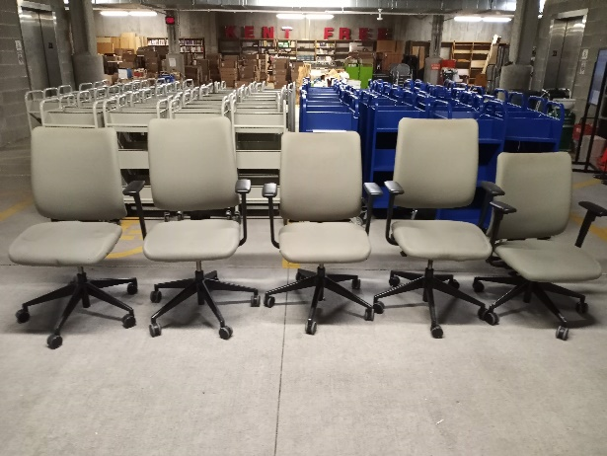

Item 2: Office chair, Green

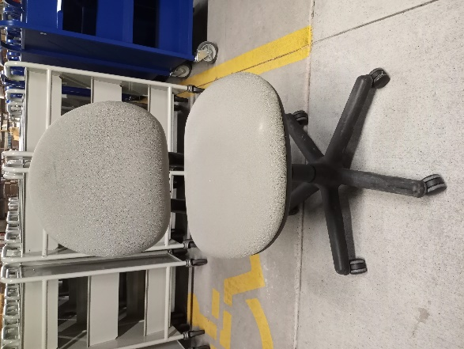

Item 3: Office chair, Black

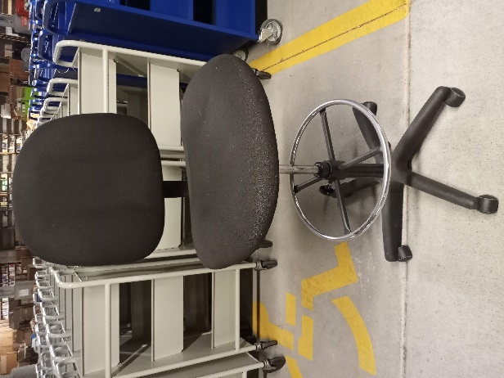

Item 4: Office chairs w/arms, Burgundy (8 available)

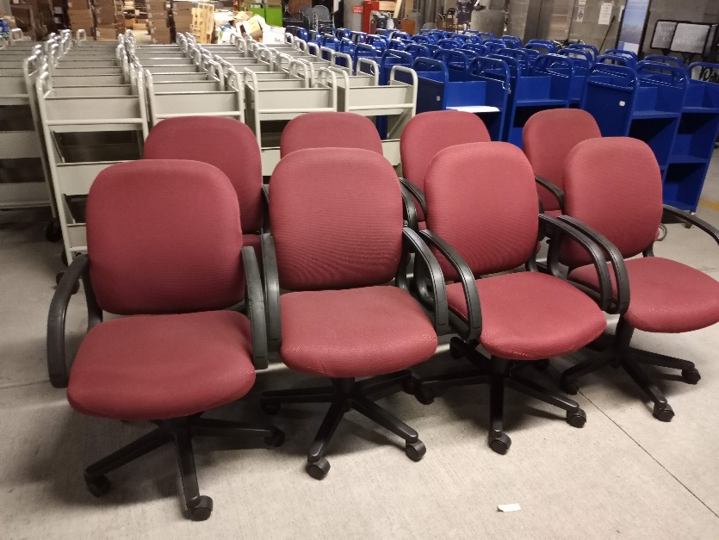

Item 5: Office chairs w/arms, Maroon (2 available)

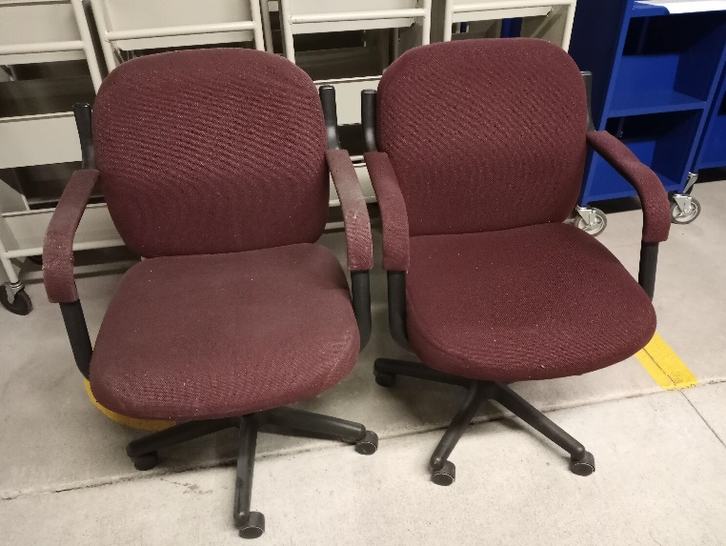

Item 6: Office chair, Maroon

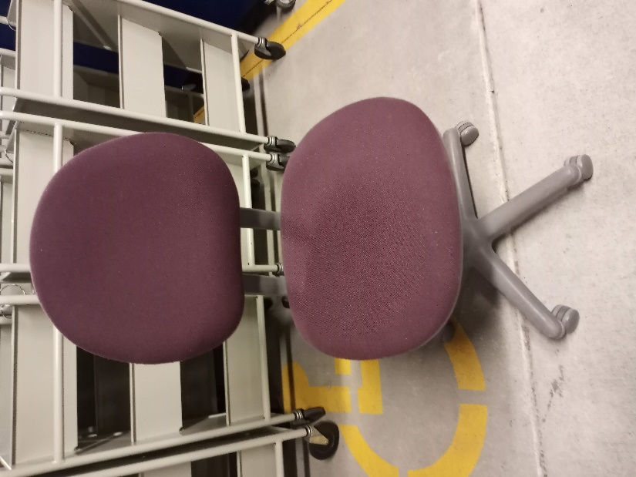

Item 7: Office chair w/arms, Gray

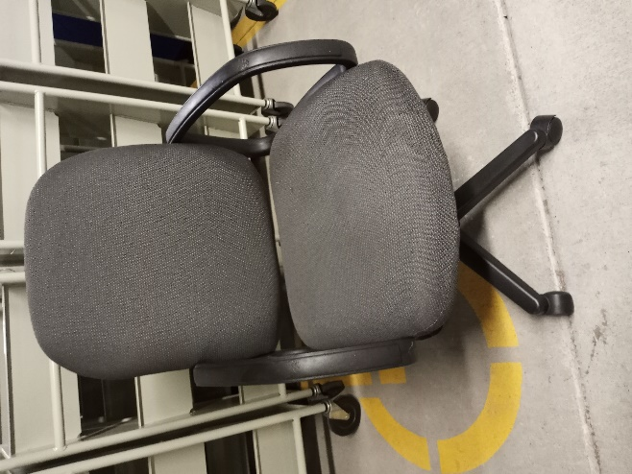

Item 8: Stacking chairs, Pink and Chrome (29 available)

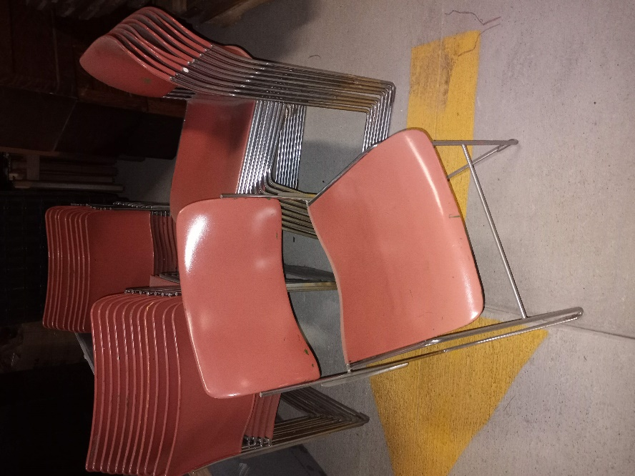

Item 9: Children’s chairs, wood, assorted colors (5 available)

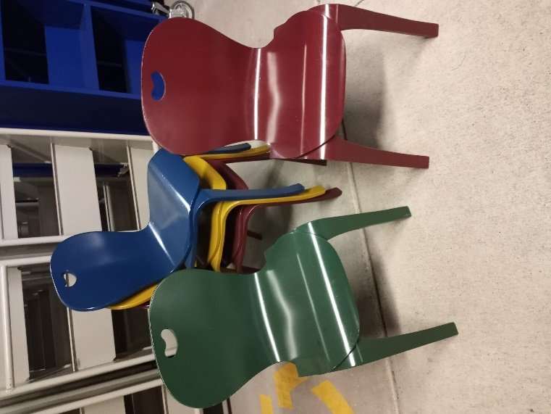

Item 10: Children’s tables, wood, natural (2 available)

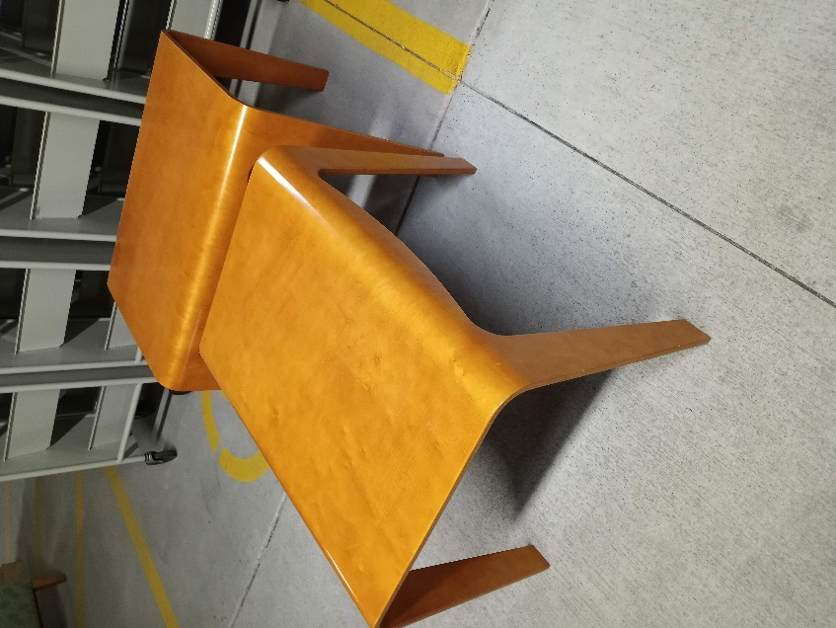
Item 11: Little Tikes kitchen playset

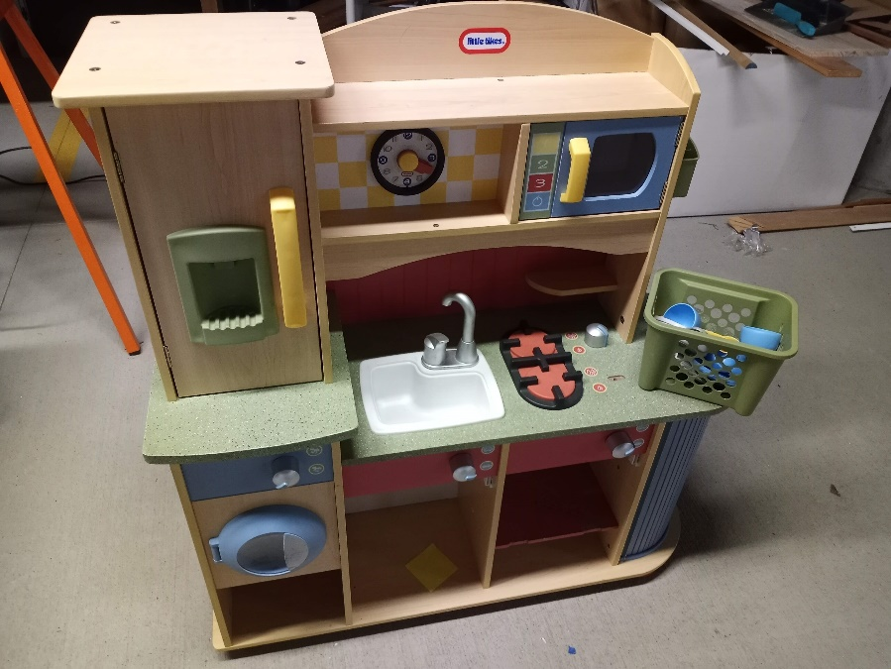

Item 12: Gressco sand table

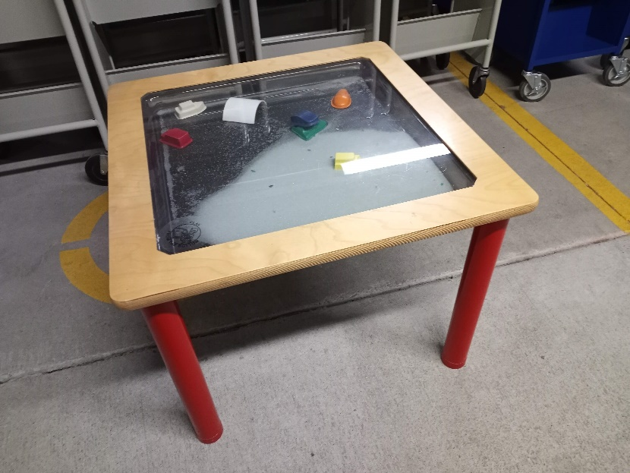

Item 13: Double sided bike rack (2 available – could use a fresh coat of paint

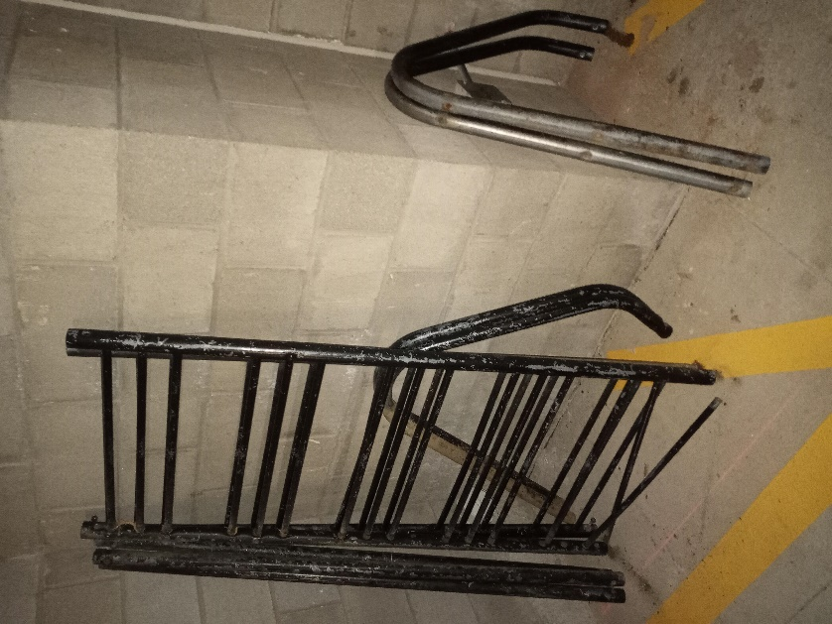

Item 14: Steel benches, missing cushions (2 available)

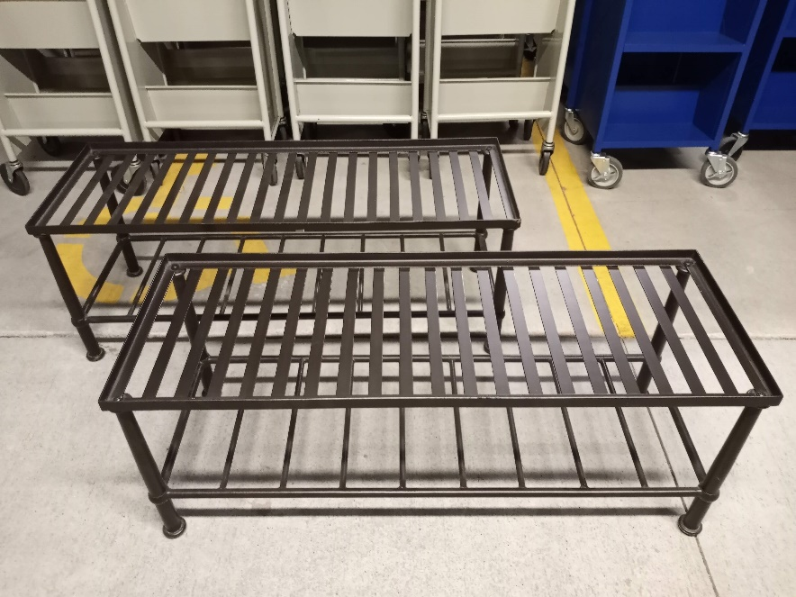

Item 15: Shelving (40)
4’ double sided steel, includes gondola, shelves and brackets

