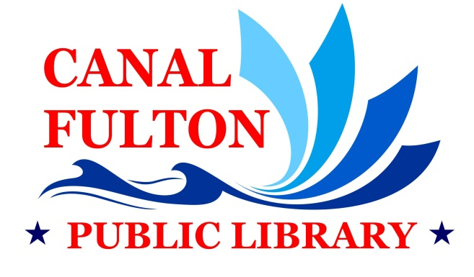
Job Announcement for Teen & Information Desk Librarian
The Canal Fulton Public Library is seeking an energetic, creative, customer service oriented professional to provide excellent library programs and services to teens, and provide reference services to all ages. The position is responsible for assisting patrons in the library, providing readers’ advisory, answering reference questions, and promoting library events. The ideal candidate must have a strong knowledge of children’s and young adult literature, experience developing and presenting innovative age-appropriate programs, a strong commitment to customer service, good interpersonal and communication skills, and experience with social and online media, services and software. For a complete job profile and application please visit www.canalfultonlibrary.org.
Qualifications:
• Bachelor’s Degree required; Master’s Degree in Library/Information Science accredited by the American Library Association preferred
• Knowledgeable about emerging technology trends
• Proficient in Microsoft Office Suite
Pay Rate and Benefits: This is a full-time (35 hours/week) position with benefits and starting pay rate of $12.36 per hour w/Bachelor’s degree, $13.65 per hour w/MLS.
Closing Date: For first consideration, apply by January 12, 2022. Applications and resumes will be accepted until the position is filled.
Instructions for Applying: Please submit an application, letter of interest, resume, and three professional references to:
David B. Brown, Director
Canal Fulton Public Library
154 Market St. E.
Canal Fulton, OH 44614
david@canalfultonlibrary.org

