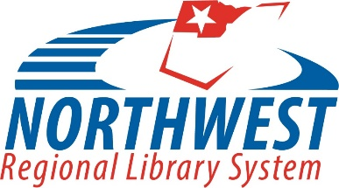
181 ½ South Main Street ~ Bowling Green, OH 43402
419/352-2903 ~ www.norweld.org

Job Advertisement
Northwest Regional Library System (NORWELD)

January 18, 2022

Continuing Education Coordinator
Northwest Regional Library System (NORWELD)
- 18 to 24 hours per week
- Starting range $17 - $22 / hour plus benefits including pro-rated vacation, holiday, and sick leave; OPERS retirement; and life insurance

Do you have a zeal for continuing education? A zest for successful events? A flair for creative programs and staff development? Join the progressive and well-supported team at the Northwest Regional Library System (NORWELD) and help shape services and programs for the Northwest Ohio library community! The ideal candidate has an enthusiasm for lifelong learning, embraces a continually adapting professional landscape, and thrives in leading and developing quality programs and continuing education opportunities that support the needs of member libraries. A knowledge of basic library operations highly desired. An ability to work both independently and collaboratively, to multitask, and excellent communication and organizational skills required.

DUTIES
The Continuing Education Coordinator is responsible for the development and management of a variety of continuing education opportunities, training, services, consulting, group meetings and events that enhance the skills, leadership, vision and knowledge of library staff in Northwest Ohio libraries.

QUALIFICATIONS
Great people skills and an enthusiasm for developing, coordinating, and conducting quality continuing education programs and events to support NORWELD member libraries operations and staff development. Excellent skills in managing multiple priorities, conducting and planning workshops, working with groups, and conducting meetings. Eagerness to learn and remain relevant in an ever-changing professional landscape. Willingness to adapt programs and events as necessary during a pandemic. Bachelor’s degree in a related field preferred or equivalent experience required.

APPLICATION
Interested parties should send a cover letter, detailed resume, and three job-related references by email to jthomas@norweld.org using the Subject “CE Coordinator.” Applications received by February 2, 2022 will receive priority consideration.

