Large 4- pc curved circulation desk. Lime green laminate top with blonde wood. Purchased in 2019 from Library Design. Lightly used.

Currently disassembled for storage and transport.

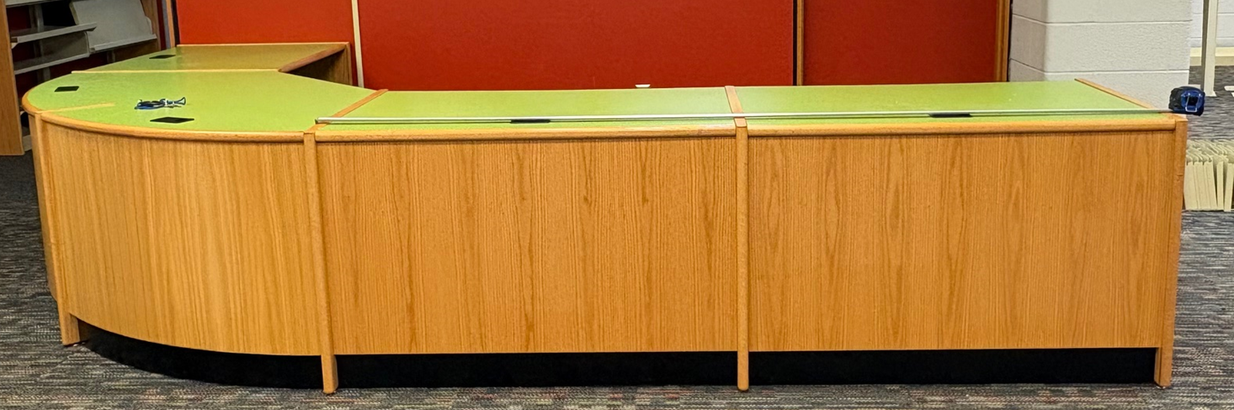

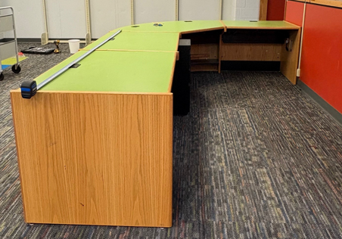 Two longest sections =90”

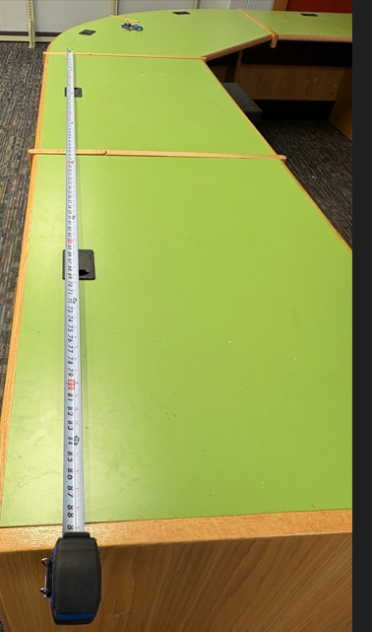

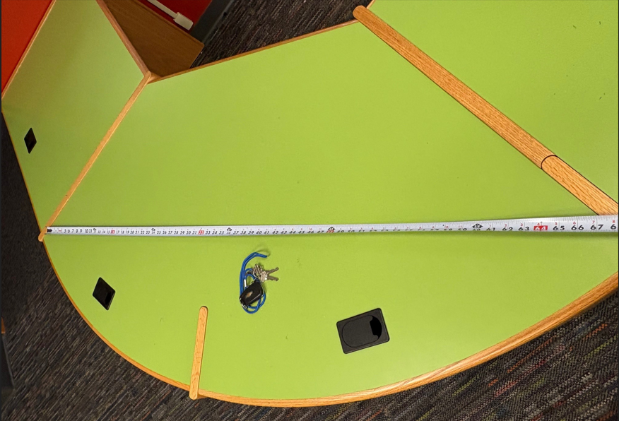 Curved Section = About 70”

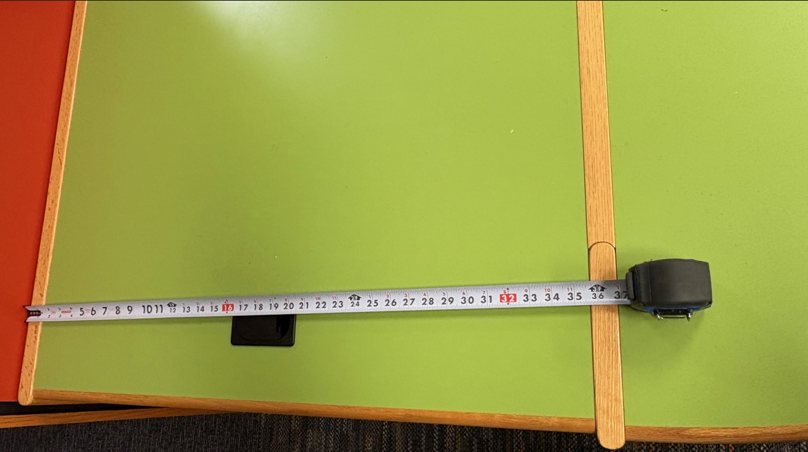 Small straight section = 36”

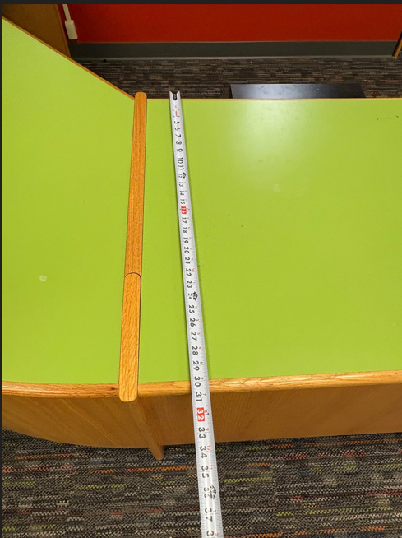 About 30” deep

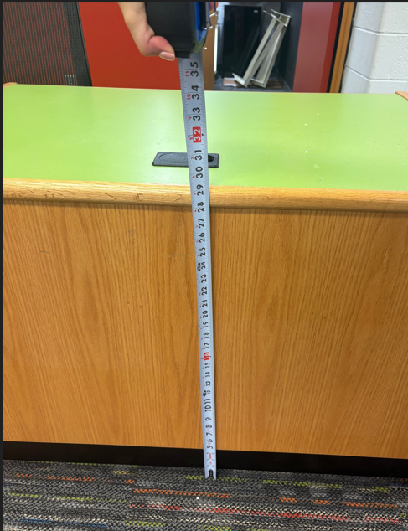 About 29” tall

