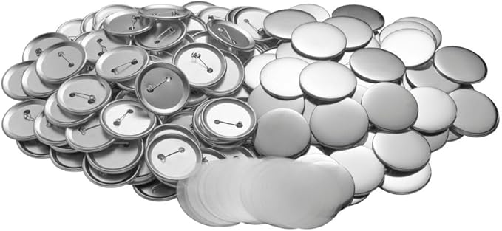

200 Sets 2.25 Inch Button Making Supplies - 58mm Button Supplies for Button Maker Machine, Pin Making Kit, Badge Maker, Button Press Supplies, Button Maker Blanks

[Brand: Navizam](https://www.amazon.com/Navizam/b/ref=bl_dp_s_web_24422774011?ie=UTF8&node=24422774011&field-lbr_brands_browse-bin=Navizam)