Bookmarks
Zinio Lady Gaga Bookmark

Zinio Lady Gaga Bookmark (Custom)

Zinio National Geographic Bookmark

Zinio National Geographic Bookmark (Custom)

Zinio Logos Bookmark

Zinio Logos Bookmark (Custom)

Zinio Overview Mini Flyer
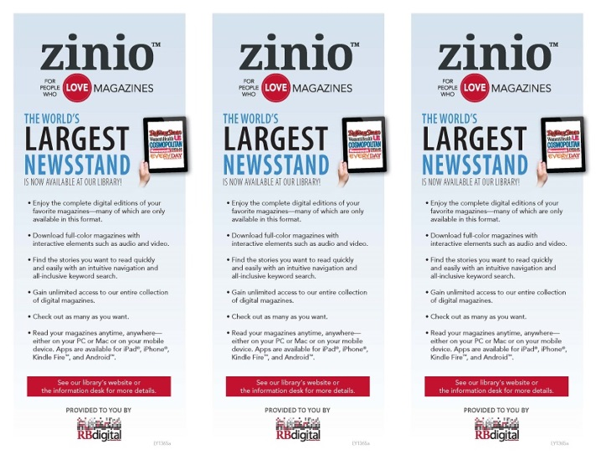
Zinio Overview Mini Flyer - Customizable
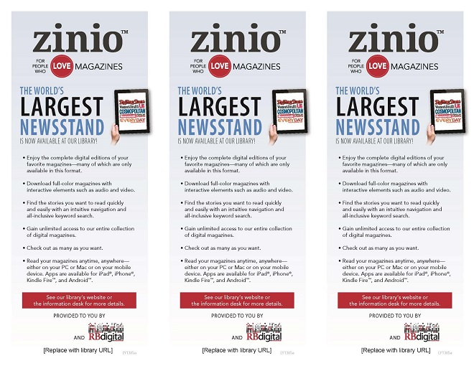
Zinio Flyer
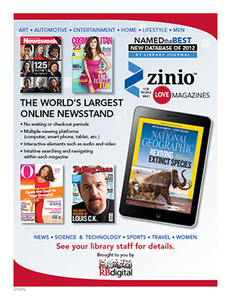
Zinio Flyer - Custom
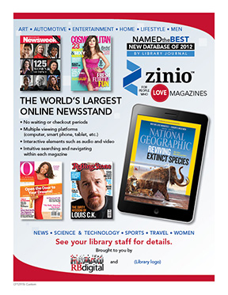
Zinio Logos Flier
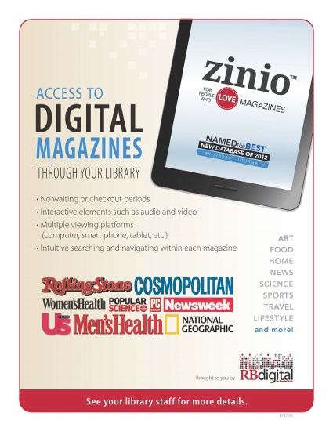
Zinio Logos Flier (Custom)
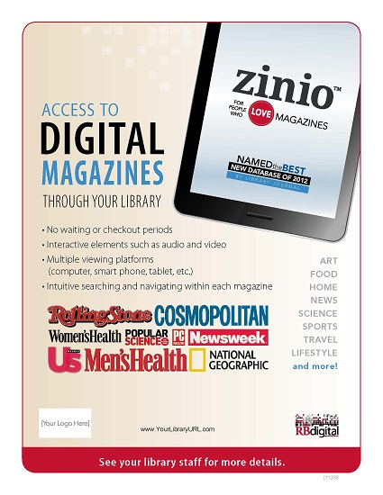
Zinio Magazine In-Use Shelf Notice - Custom
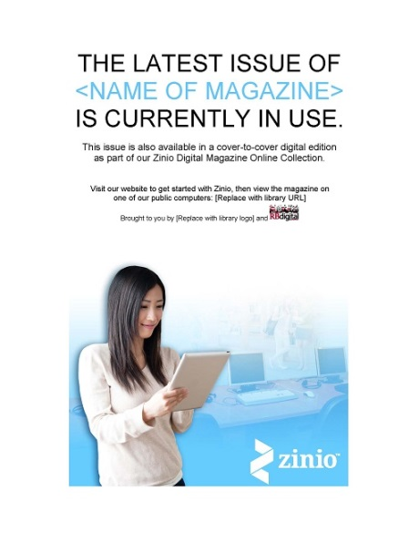
Zinio Account Setup Flyer
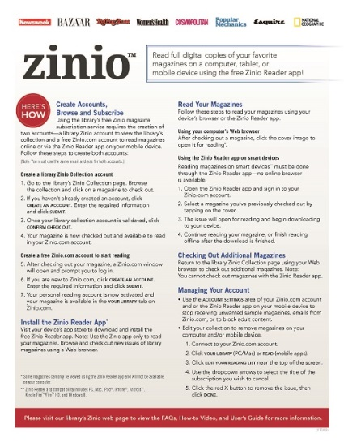
Zinio Account Setup Flyer - Custom
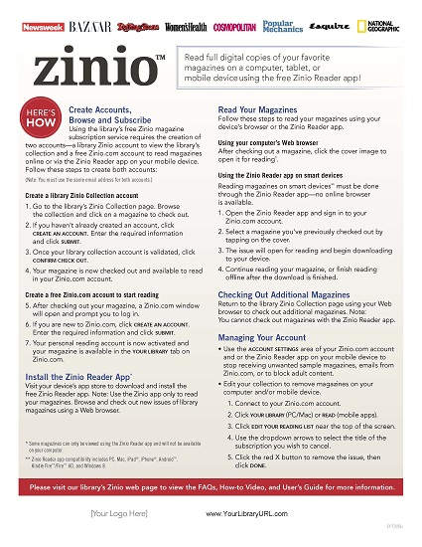
Poster
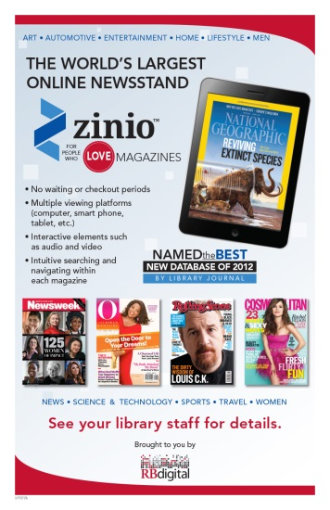
Poster – Custom
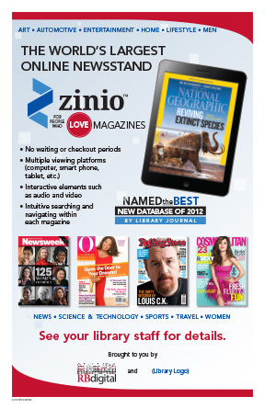
Zinio Logos Poster
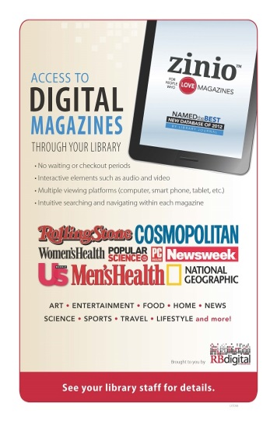
Zinio Logos Poster (Custom)
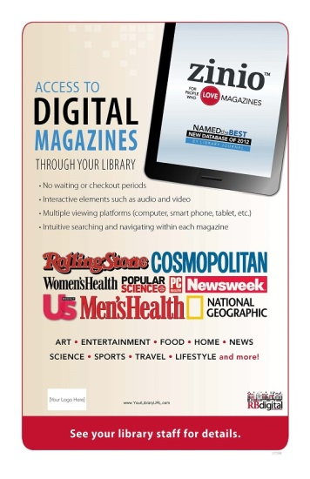
National Geographic Poster

National Geographic Poster (Custom)

Teen Tech Week poster
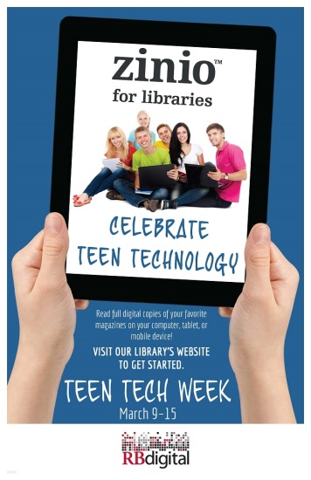
Teen Tech Week QR Code Poster
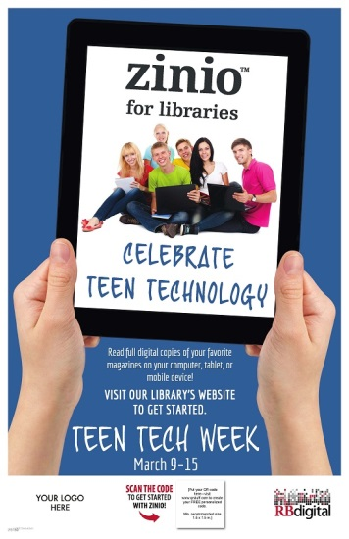
Shelf Talkers
Shelf Talker

Shelf Talker Custom

Logos Shelf Talker

Logos Shelf Talker_Custom

QR Code Shelf Talker
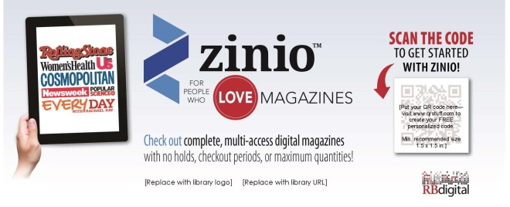
QR Code Frame-able 5x7
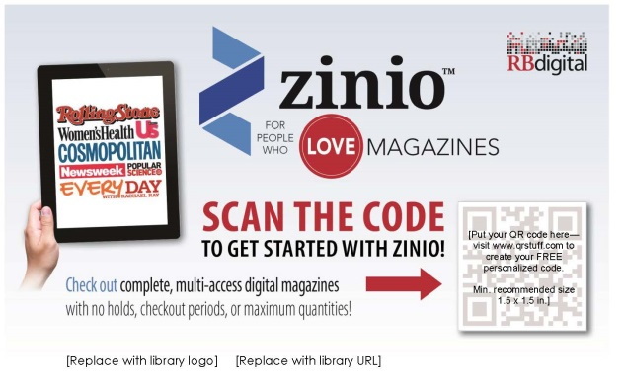
PowerPoint
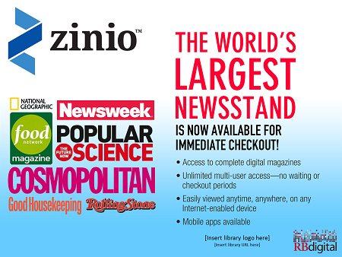
Zinio Magazine Label - Custom
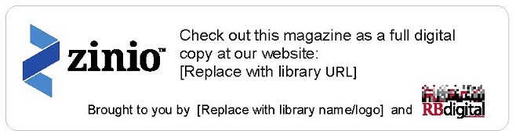
Web Buttons & Banners
Zinio Now Available Web Button

Zinio Vertical Web Banner

Zinio Web Banner

Zinio Logos Web Banner

Zinio Back Issues Available Image

Zinio Magazines Web Banner

Zinio iPhone Web Banner

Zinio Laptop Web Banner

News/Business Logos Web Banner

News/Business Covers Web Banner

Logos
Zinio (Print)

Zinio (Web)

Zinio for Libraries (Print)

Zinio for Libraries (Web)

Zinio Love Magazines (Print)

Zinio Love Magazines (Web)

Press Releases
Press Release (100 Words)
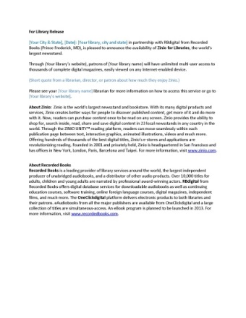
Press Release (200 Words)
