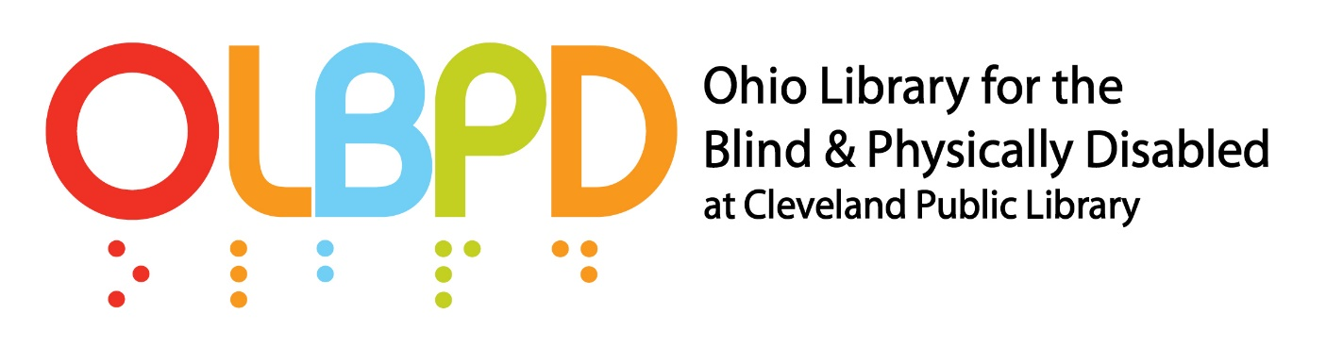
ASSISTANT MANAGER - OHIO LIBRARY for the BLIND & PHYSICALLY DISABLED
This is a Full time (37.50 hours per week) – Salaried opportunity at $33.01 per hour
The Ohio Library for the Blind and Physically Disabled (OLBPD) is part of the Cleveland Public Library.
In partnership with the State Library of Ohio Talking Book Program, OLBPD serves as the Regional Library for the National Library Service for the Blind and Print Disabled (NLS) of the Library of Congress, and administers a free library program of braille and audio materials circulated to eligible borrowers in the State of Ohio by postage-free mail.

OLBPD and the State Library of Ohio Talking Book Program received the 2010 National Library Service Network Library of the Year Award.

The Cleveland Public Library strives to be the driving force behind a powerful culture of learning that will inspire Clevelanders from all walks of life to continually learn, share, and seek out new knowledge.

The successful applicant will be a self-directed professional with a strong work ethic, high energy and enthusiasm, a collaborative work style, and the skill set to thrive in a welcoming service environment for patron and staff.

Job Summary: This position is responsible for supporting the day-to-day operations of OLBPD, including supervising staff, performing community outreach and engagement and collaborating with other CPL departments and staff.

Qualifications:
Education: Bachelor’s degree required, Masters preferred, ideal candidate will have a Master’s degree in Library Information science from an ALA accredited college or university.

Experience:
- 2 years supervisory experience, preferably in a union environment.
- 2 years’ experience working for an organization that provides community-based services, preferably in an urban setting.
- 2 years’ experience reading, transcribing and editing braille correspondence.
- 2 years’ experience supporting persons with disabilities preferred.
- Familiarity with Revised Standards and Guidelines of Service for National Library Service network libraries preferred
Key Essential Duties and Responsibilities include:
- Plan and manage the day-to-day operations of OLBPD.
- Coordinate, schedule, supervise and assign work assignments to staff and volunteers. Provide direct supervision of staff including orientation, training, discipline, and performance evaluations. Comply with collective bargaining agreement(s). Ensure staff provide exceptional customer service to Library patrons and visitors.
- Create and maintain bibliographic records, including subject heading classifications used by ILS for auto assigning books to patrons.
- Maintain patron applications as required by NLS, including verifying accuracy of application data entered into ILS, storage, retrieval, and proper disposal.
- Coordinate day-to-day circulation and materials handling activities and staff, including duplication-on-demand and mail delivery service of materials, and inventory and shelf maintenance.
- Act as lead for ILS system operations and staff support, including performing routine maintenance updates, coordinated with IT staff.
- Plan and implement programming. Coordinate library services to schools, and outreach geared for children and young adults, including working with teachers of the visually impaired throughout the State; participate in CPL youth services meetings and coordinate OLBPD participation in summer lit league activities through the State.
- Coordinate library services to State prisons, maintaining communications with librarians at correctional facilities on administration of library services.

Qualified candidates will have excellent interpersonal and decision-making skills; with demonstrated technical and time management abilities; display a professional attitude and appearance; and exhibit pro-active and creative problem-solving skills.

To Apply:
Please apply at www.cpl.org and attach a current resume and cover letter.
Please direct any questions to: hr.office@cpl.org

If you require reasonable accommodation in completing this application, interviewing, completing any pre-employment testing, or otherwise participating in the employee selection process, please direct your inquiries to Althea Johnson, Human Resources, althea.johnson@cpl.org , 216-902-4962.

