

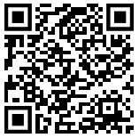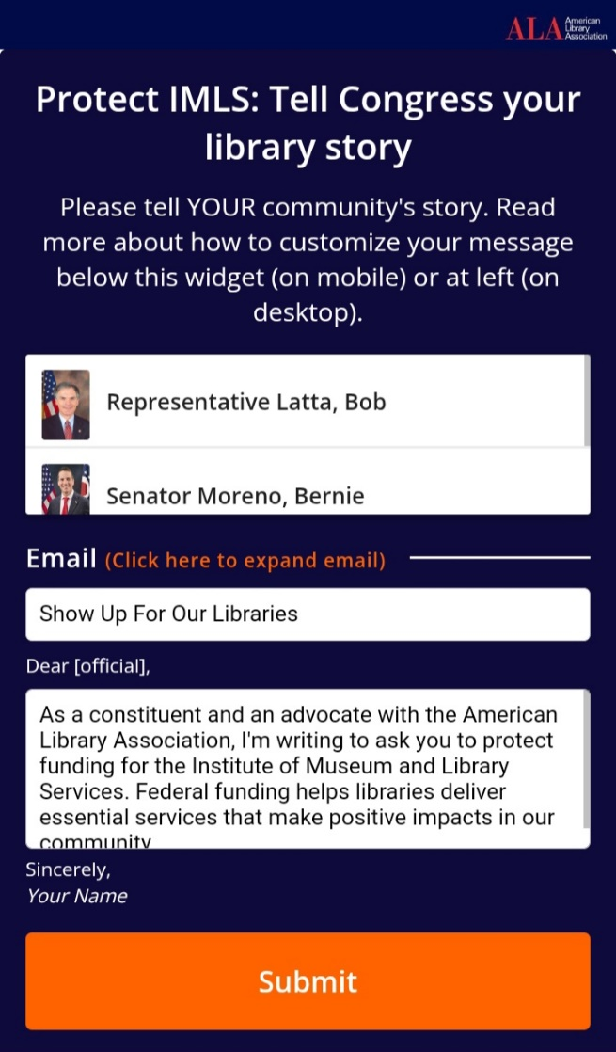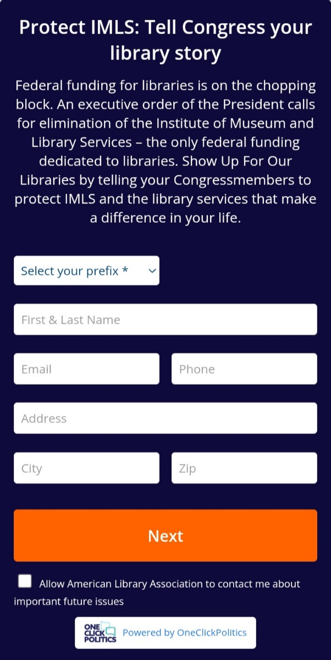

Fill out this information (uncheck the box at the very bottom)

**Scan this QR code to save libraries (and museums)**

**THANK YOU!!**

Everything is already filled in on the next page. Just hit **SUBMIT**!